NOAA Technical Report NWS 45
UNITED STATES OF AMERICA
DEPARTMENT OF COMMERCE

NOAA NWS Distributed Hydrologic Modeling Research and Development

Michael Smith
Victor Koren
Ziya Zhang
Seann Reed
Dongjun Seo
Fekadu Moreda
Vadim Kuzmin
Zhengtao Cui
Richard Anderson

April 2004

U.S. DEPARTMENT OF COMMERCE
National Oceanic and Atmospheric Administration
National Weather Service
NOAA NWS Distributed Hydrologic Modeling Research and Development
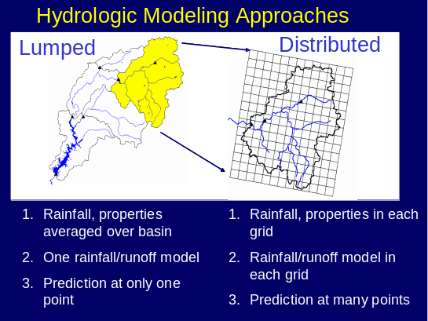


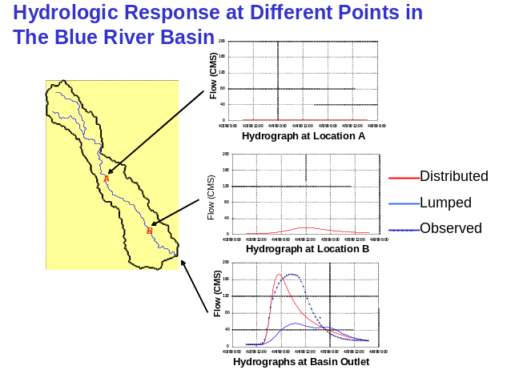

Victor Koren taking cross section measurements, Blue River, Oklahoma

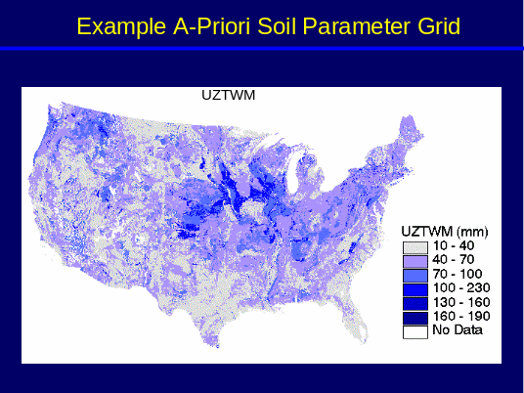
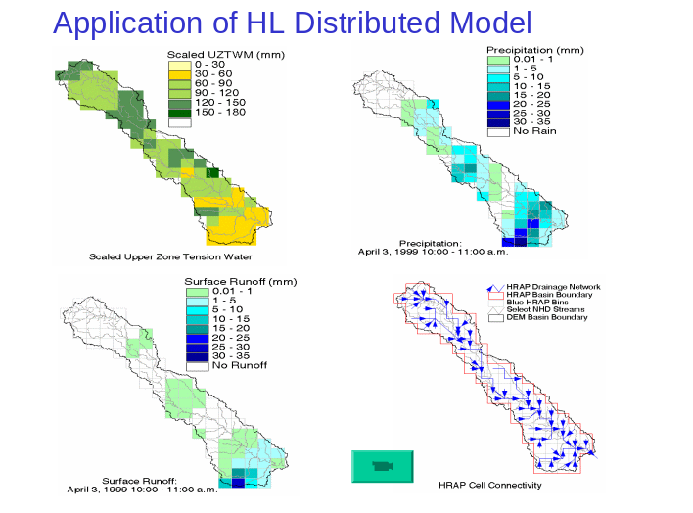
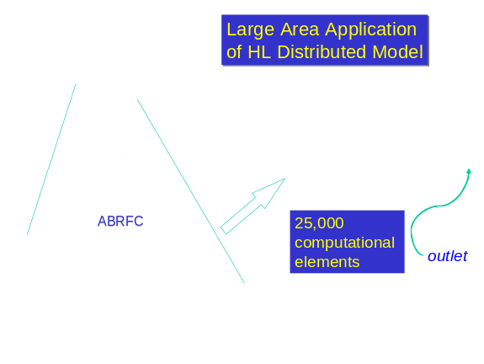

The Distributed Model Intercomparison Project: DMIP

Executive Summary

The Hydrology Laboratory (HL) of the NOAA National Weather Service Office of Hydrologic Development (NWS OHD) began its distributed modeling research in 1992. It has followed a strategy defined by two phases. In Phase 1, the research focused on developing methods of fully realizing the potential information in the NEXRAD precipitation estimates using models within the existing NWS river forecast system. In Phase 2 of this research, HL has aggressively pursued the development of a fully distributed parameter hydrologic model. Phase 2 is characterized by the concurrent in-house development of the NWS’s first distributed model and the launching of the Distributed Model Intercomparison Project (DMIP). Twelve groups participated in this highly successful intercomparison, including representatives from China, New Zealand, Denmark, Canada, as well as leading institutions in the U.S. The distributed model developed by HL performed well in DMIP, leading to the conclusion that HL is on a sound path of research and development for operational distributed hydrologic modeling.
In the course of HL research, at least 25 peer-reviewed papers have been published in leading scientific journals, attesting to the scientific validity of the HL R&D. Numerous US and international oral and poster presentations have been made, as well as five NWS-organized sessions at AGU conferences on the comparison of lumped and distributed models and related issues. HL scientists have been invited to give oral presentations on two occasions, and one has been invited by the Journal of Hydrology to be Guest Editor of a Special Issue of the Journal on the DMIP project. Along the way, new tools and procedures have been consistently delivered to the field.
Research and development of distributed hydrologic models has progressed to the point of prototype deployment of the NWS distributed model at the Arkansas-Red Basin, Colorado Basin, Mid-Atlantic, and West Gulf River Forecast Centers. Moreover, HL is launching an effort to begin in-house runs of its distributed model executed over the CONUS domain. In addition, a significant software engineering project is underway to deliver a fully supported distributed model compatible with the NWS officially-supported computational environment for forecast operations.

Contents
1 Introduction 7
2 Purpose 7
3 Motivation for Distributed Modeling Research and Development. 7
4 Overall Research and Development Strategy 8
5 Phase 1 Research 9
5.1 Phase 1 R&D Strategy 9
5.2 Phase 1 Goals 9
5.3 Phase 1 Constraints 11
5.4 Major Issues Investigated in Phase 1 13
5.5 Major Findings from Phase 1 13
5.6 Tools and Models Developed in Phase 1 20
5.7 Phase 1 Associated Collaborative Research 20
6 Phase 2 Research and Development 21
6.1 Phase 2 Scope 21
6.2 Phase 2 Goals 21
6.3 Phase 2 Constraints 22
6.4 Phase 2 R&D Strategy 22
6.4.1 Internal HL Distributed Model Development 23
6.4.1.1 HL-RMS parameterization using DEM-GIS data 25
6.4.1.2 Estimation of SAC-SMA parameters 27
6.4.1.3 Estimation of routing parameters using DEM and channel hydraulic data 28
6.4.1.4 Large Area applications of HL-RMS 29
6.4.1.5 Prototype Application of HL-RMS 32
6.4.2 The Distributed Model Intercomparison Project (DMIP) 35
6.4.2.1 Background for DMIP 35
6.4.2.2 DMIP Schedule 36
6.4.2.3 DMIP Study Area 37
6.4.2.4 DMIP Participants 37
6.4.2.5 Major Findings from DMIP 38
6.4.2.6 Future DMIP Phases 42
6.5 Tools and Procedures from Phase 2 R&D 42
6.6 Collaborative Research Associated with Phase 2 R&D 43
7 Distributed Modeling for Flash Flood Forecasting 44
8 Distributed Modeling Software Engineering and Implementation 46
9 References 47
Appendix I: Publications and Presentations from Phase 1 Research 52
Appendix II: Publications and Presentation from Phase 2 54
Appendix III: Acronyms 58
Appendix IV: Proposed Field Office Transition from Lumped to Distributed Modeling 59
Appendix V: Needs for Continuing HL R&D 63

List of Tables

Table 1. Tools, Procedures, and Guidelines developed from Phase 1 R&D. 20
Table 2 Schedule for Major DMIP Activities 36
Table 3. Tools developed and delivered as a result of Phase 2 research and development 43

List of Figures

Figure 1. Overall timeline and major tasks for Phase 1 (yellow) and Phase 2 (green) of NWS HL distributed modeling research and development. 10
Figure 2. Location of NEXRAD radar sites and coverage of Phase 1 and Phase 2 study basins. Circles denote the coverage of each radar. Radius of the radar umbrella is 230 km. These basins were also used in the Distributed Model Intercomparison Project (DMIP). (Source: Smith et al., 2004a.) 11
Figure 3. Components of the NWSRFS (Source: Smith et al. 2003; Johnson et al.,1999) 12
Figure 4. (Following pages). Spatially-aggregated Stage III precipitation field over Northeastern Oklahoma, January 16, 1994 at 20:00Z. 15
Figure 5. Relative sensitivity of SAC-SMA runoff components to size of computational area, keeping model parameters constant. Runoff values are normalized by the value at the 8x8 HRAP bin scale. (Source: Finnerty et al., 1997) 18
Figure 6. Scale dependency of total runoff, simulated by different models, and expressed in percent change in surface runoff as compared to the finest scale value. (Source: Fig 4 of Koren et al., 1999; Figure 2-15 of Smith et al. 1999- NWS 44: Distributed Modeling: Phase 1 Results 18
Figure 7. Relative simulation improvement versus level of sub-basin scale (disaggreation) for various degrees of noise in input forcing. (Source: Koren et al., 2003) 19
Figure 8. HL-RMS treatment of computed flows. A. Cell flow directions and connectivity for the Blue River basin in Oklahoma. Drainage area is 476 sq. mi. B. Conceptual representation of overland flow segments feeding a single channel in each HL-RMS computational cell. 24
Figure 9. Schematic for parameterizing the water balance and channel routing components of HL-RMS 26
Figure 10. A priori estimates of the SAC-SMA model upper zone tension water depth in mm for the CONUS domain. Cell resolution is 1km² 29
Figure 11 Large-area implementation of HL-RMS over the Arkansas River basin. 30
Figure 12. Observed and derived fields from the large-area application of HL-RMS. 31
Figure 13. Large-Area Application of HL-RMS: Initial discharge simulation of the entire Arkansas River Basin 32
Figure 14. Location Map of Sites for HL-RMS Prototype Implementation. Colored areas are the domain extents of the NWS River Forecast Centers. 33
Figure 15. Location of the Susquehanna River and its sub-basins for prototype implementation of HL-RMS. 34
Figure 16 Study basins used in DMIP (source: Smith et al., 2004a) 38
Figure 17. Improvement of Distributed Model over Lumped SAC-SMA for different DMIP basins and models. Results are for calibrated lumped and distributed models. The basins are segregated into parent basins and interiorcomputational points. Positive values of improvement indicate the distributed model performed better than the NWS calibrated lumped SAC-SMA model 40
Figure 18. Relationship between storm rainfall center-of-mass (rainfall location index) and a basins ability to dampen the input rainfall signal (dampening ratio) for three DMIP basins. (Source: Smith et al. 2004b) 42
Figure 19. Application of the Distributed model HL-RMS to the Blue River, OK. Approximately 80 computational elements are used in this application. 44
Figure 20. Hydrograph Generation at various points in the Blue River basin illustrating the use of a distributed model for flash flood forecasting at interior locations. 45

Introduction
The National Weather Service (NWS) has a mandate to provide forecasts for the Nation’s rivers. To fulfill this mission, the NWS uses its River Forecast System (NWSRFS) at 13 River Forecast Centers (RFCs) to provide daily stage forecasts at over 4,000 points. Within the NWSRFS are algorithms for hydrologic and hydraulic models as well as procedures for data ingest, display and analysis of results, and other functions. Research and development to support the NWSRFS is conducted within the Hydrology Lab (HL) of the NWS Office of Hydrologic Development (OHD). Interested readers are referred to Fread et al. (1995), Larson et al. (1995), and Stallings and Wenzel (1995) for more information regarding the forecast mission of the NWS and the structure of the NWSRFS.
The NWS HL of conducts scientific research, data archival and analysis, and software engineering to support the river and flash flood mission of the NWS. HL initiated research and development into distributed hydrologic modeling in 1992. Since that time, HL has directed increasing resources toward this important effort. Significant research and development is taking place in HL in conjunction with major collaborative efforts with leading universities and other institutions.

Purpose

This document serves as both an overview of past research and development as well as a plan for continued work. While this report will present an overview of the findings of the research to date, details of the findings and conclusions can be found in the cited journal papers.

Motivation for Distributed Modeling Research and Development.

Beven (1985) and numerous other authors since then have described and promoted the advantages of distributed modeling. Indeed, distributed hydrologic models have been in development for almost three decades. Early efforts to develop distributed hydrologic models were hampered by limited computational capacities and seemingly huge storage requirements. Currently, exponentially increasing computing speeds and storage capacities have largely removed the traditional barriers to distributed modeling, bringing them ever closer to the operational environment.
The NWS recognizes these advantages and views distributed modeling as a critical pathway through which new scientific advances can be infused into the NWSRFS (Carter, 2002; Koren et al., 2001). Recently, the National Academy of Sciences listed hydrologic forecasting as one of the grand challenges in environmental sciences (NAS, 2001). The NWS sees distributed modeling as one important approach to meeting this challenge. Moreover, distributed modeling is identified as one of the ways the NWS can improve the accuracy of its river and flash flood forecasts so as to meet stated goals (NWS, 1999). The NWS also recognized the recommendations by the NAS review (1996) regarding the need to develop topographically-based models. Moreover, distributed modeling is a more scientifically valid approach to the prediction of flash floods than the current fielded tools.
Given the scale of the NWS mission and the recommendations from external reviewers, it was clear that an accelerated program was needed to move the NWS research in the proper direction for operational distributed modeling. While numerous distributed models exist and indeed some are moving into the operational forecasting environment (e.g., Koren and Barrett, 1994; Turcotte et al. 2003) it is not clear from the literature which distributed model or modeling approach is best to improve the NWS forecasting capabilities. Therefore, a significant effort was begun to investigate distributed models for operational river and flash flood forecasting.

Overall Research and Development Strategy

HL’s strategy for developing distributed models for operational river and flash flood forecasting has involved two primary phases as shown in Figure 1. Plans for Phase 1 Research were initiated by Lindsey (1993, 1994) and later modified by Smith (1996). In Phase 1, we focused on the questions: “What can we learn about distributed data sets and current capabilities in NWSRFS? How can we take advantage of the NEXRAD precipitation information to improve forecasting using existing NWSRFS models and procedures? Can we improve lumped simulations using NEXRAD data? Is semi-distributed modeling of existing forecast basins a reasonable alternative?
In Phase 2 of the distributed modeling R&D, the concept of distributed parameters as well as distributed inputs is investigated, capitalizing on the significant experience gained in Phase 1. Phase 2 R&D embodies a major effort of scientific development not constrained by the structure of the current NWSRFS.
As shown in Figure 1, HL research has been augmented by collaborative research with MIT, the University of Arizona, and the Hydrologic Research Center in both phases of work.
Figure 2 presents the location of the study basins used in Phase 1, Phase 2, and also the Distributed Model Intercomparison Project (DMIP). These basins were selected for their good radar coverage, the lack of complications such as snow and orographics, and the availability of USGS observed hourly discharge data at basin outlets and a few interior points.

Phase 1 Research

Phase 1 R&D Strategy

In Phase I of this research we investigated lumped and semi-distributed applications of the Sacramento Soil Moisture Accounting Model (SAC-SMA) (Burnash, et al., 1973) using basin and sub-basin mean areal averages of the NEXRAD 4km gridded precipitation estimates. In the semi-distributed scenario, existing NWS forecast basins are disaggregated into a number of sub-basins, each having a SAC-SMA model and a unit hydrograph. Channel routing was accounted for in two ways; an extended unit hydrograph and explicit Muskingum channel routing from the outlet of one sub-basin to the next downstream outlet. In this way, minimal system changes would be needed but a great deal of scientific understanding could be gained.

Phase 1 Goals

Several goals were outlined for Phase 1 research with the anticipation that much would be learned that would provide a strong foundation for Phase 2 R&D:

1. Develop a methodology to use and evaluate the utility of NEXRAD gridded rainfall data with the models currently available in NWSRFS. Lumped and semi-distributed approaches were investigated
2. Study the effects of increasing the spatial and temporal resolution on hydrologic model response and parameters.
3. Develop guidelines, tools, and recommendations to help the RFC’s use gridded rainfall data within the NWSRFS framework.
4. Modify the lumped Sacramento Soil Moisture Accounting Model (SAC-SMA) to account for a statistical representation of the rainfall spatial variability.

‘92 | ‘93 | ‘94 | ‘95 | ‘96 | ‘97 | ‘98 | ‘99 | ‘00 |  |  | ‘01 | ‘02 | ‘03 | ‘04 |  |  | ‘05 | ‘06 | Beyond
Phase 1: Use of NEXRAD data with existing NWSRFS models
Project plan |  | Basin selection  Data collection |  |  | Lumped modeling  -existing SAC-SMA  -reformulated SAC-SMA
 |  |  |  | Scaling studies
Semi-distributed modeling
-UHG routing
-Muskingum-Cunge channel routing
Colloborative Research
-MIT: development of complex physically-based distributed model
-HRC: development of SAC-SMA based distributed model, sensitivity to radar, parameter uncertainty
-Arizona: lumped and semi-distributed model calibration
Phase 2: Full Distributed Modeling
continuing
Parameterization: soils-based SAC-SMA parameters
-STATSGO data
-SSURGO data
HL-RMS development
-basic version
-Continuous API model
-snow
- Muskingum Cunge
 |  |  |  |  |  |  | DMIP Phase 1 |  |  |  |  |  | DMIP Phase 2
 |  |  |  |  |  | Collaborative Research  MIT: state-of-art physically based  HRC: effects of parameteric, NEXRAD uncertainty  Arizona: calb. of semi-distributed models  U. Minn: probabilistic channel routing parameters |  |  |  |  |  |  |  |  | Future Collaborative Research  NWS competitive program

Figure 1. Overall timeline and major tasks for Phase 1 (yellow) and Phase 2 (green) of NWS HL distributed modeling research and development.
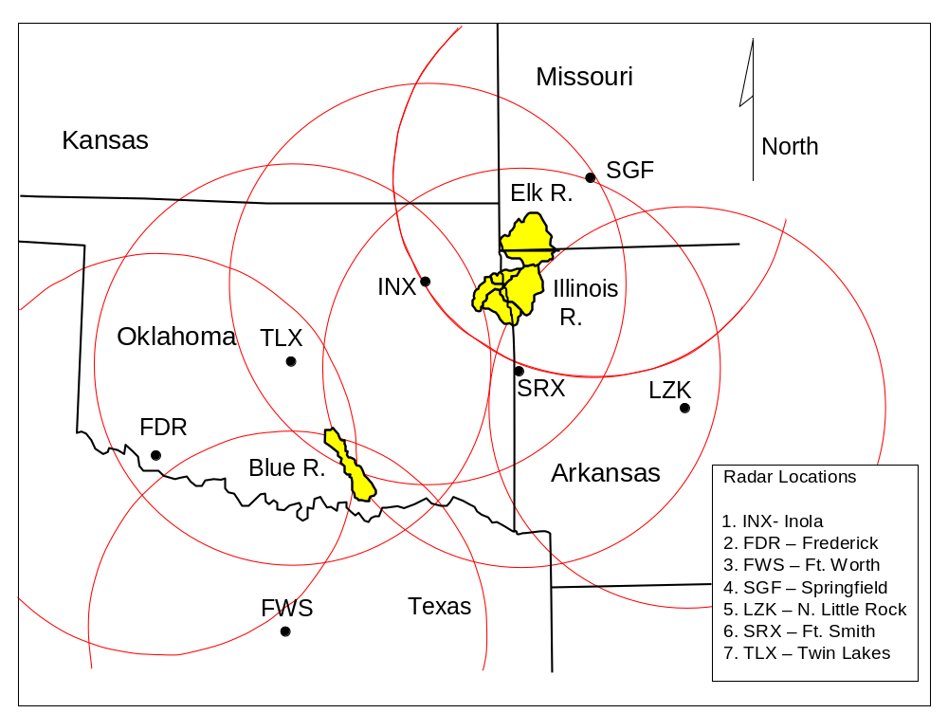
Figure 2. Location of NEXRAD radar sites and coverage of Phase 1 and Phase 2 study basins. Circles denote the coverage of each radar. Radius of the radar umbrella is 230 km. These basins were also used in the Distributed Model Intercomparison Project (DMIP). (Source: Smith et al., 2004a.)

Phase 1 Constraints

Phase 1 R&D operated under several constraints. The structure and philosophy of the NWSRFS places unique constraints on the development of distributed modeling approaches.
To begin, a brief review of the current forecast system is warranted here. Figure 3 presents the major components of the NWSRFS. In the Calibration System (CS), time series of historical forcings are prepared and model parameters are calibrated. In the Operational Forecast System (OFS), real time data are used with the calibrated hydrologic and hydraulic models to produce forecast river stages several days into the future. The Interactive Forecast Program (IFP) allows the hydrologist to make manual run-time adjustments to account for non-standard conditions. The historical time series of precipitation, temperature, and potential evaporation are used to generate a suite of long term probabilisitic forecasts weeks or months into the future in the Ensemble Streamflow Prediction system (ESP). Initial conditions for ESP simulations are taken from the current model states as computed by the OFS. Statistical procedures are used to quantify the uncertainty of these forecasts within a designated window.

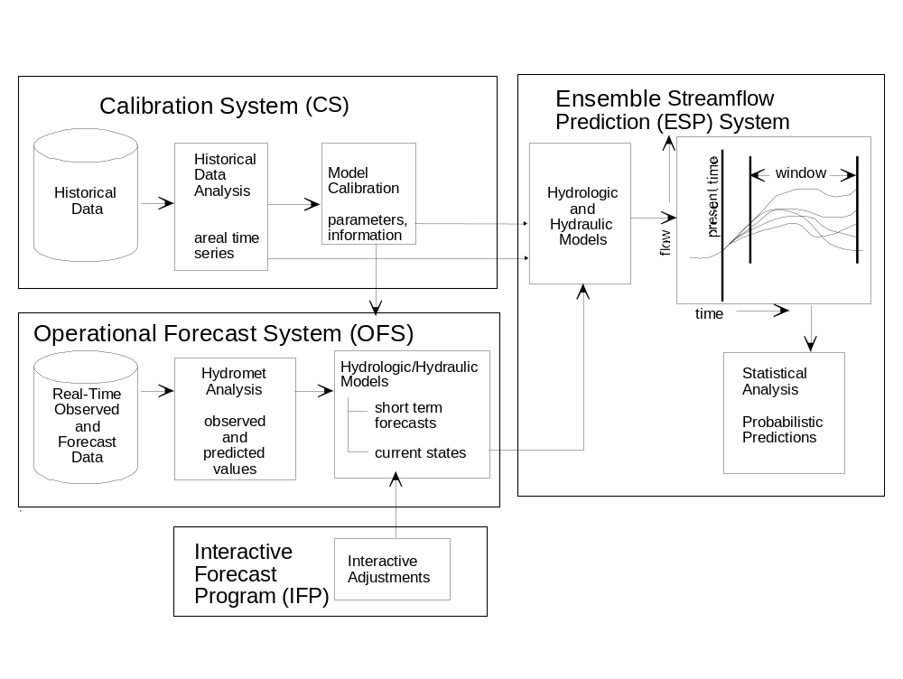

Figure 3. Components of the NWSRFS (Source: Smith et al. 2003; Johnson et al.,1999)

As envisioned in Phase 1, any lumped and semi-distributed modeling techniques had to fit into the existing framework of the NWSRFS. Gridded data fields can be input into the NWSRFS and spatially averaged to create a time series of mean-areal values of precipitation. However, NWSRFS cannot currently pass gridded data and parameters through its models to generate gridded output fields to support fully distributed modeling. Also, a question facing Phase 1 (and still faces Phase 2 research) is: Can a distributed model used for RFC basin outlet forecasts and interior flash flood forecasts also be used for long term ensemble streamflow forecasts? Computational efficiencies cloud the issue here.
Other constraints include the necessary around-the-clock operations schedule of the NWS field offices. Models must be able to run continuously, with many built in fail-safe procedures.

Major Issues Investigated in Phase 1

The following issues were investigated in Phase 1 research:

1. Comparison of rain gage precipitation and radar precipitation estimates. The issue underlying this effort was the differences in the data used for model calibration and operational forecasting. Is recalibration necessary if a model is calibrated using data from a network of rain gages while using NEXRAD radar precipitation estimates for operational forecasting?
2. Sensitivity of the SAC-SMA parameters to different space-time scales of precipitation forcing.
3. Sensitivity of different hydrologic models to different space-time scales of precipitation forcing. As shown in Figure 4, spatially averaging a typical precipitation field from the NEXRAD radar will result in a smoothed input signal to hydrologic models operating at the scale of averaging.
4. Development of local area unit hydrographs using GIS data.
5. Level of disaggregation to achieve improved basin outlet simulations.
6. Development of a reformulated version of the lumped SAC-SMA model to account statistically for the spatial distribution of rainfall.

Major Findings from Phase 1

We summarize the major findings of our research here:

1. Rain gage and radar estimates of precipitation have different statistical properties. Moreover, these statistical properties of the radar precipitation estimates change in time with the algorithmic changes in the NEXRAD processing system. Care must be taken when calibrating a model with rain gage data and forcing with another data source at the same spatial scale (corroborated later by Stellman and Fuelberg, 2001; Bradley and Kruger, 1998; and Young et al. 2000 (with credit given to HL staff D. Johnson, Mike Smith, D.-J.Seo). This finding underscores the great need to perform re-analysis of the NEXRAD data to produce stationary data sets for research and model calibration.

2. The conceptual SAC-SMA model is sensitive to the time and spatial scale of the precipitation inputs. Therefore, the NWS cannot transition from forecasting using rain gage derived 6-hour precipitation estimates to hourly lumped forecasting without model recalibration. Recalibration is necessary when transitioning from a 6 hour time step to a one hour time step, or when disaggregating a lumped basin into a number of constituent sub-basins for semi-distributed modeling. Figure 5 shows the relative sensitivity of the SAC-SMA runoff components. Simulations were conducted by examining the runoff behavior from a 64x64 HRAP bin synthetic basin in the ABRFC domain shown in Figure 4. This basin was modeled as a series of coarser and coarser computational elements for which the rainfall was averaged as seen in Figure 4.

3. Semi-distributed modeling is a valid approach to improve the accuracy of forecasts at NWS forecast points compared to lumped modeling. This was shown for the Blue River in Oklahoma using an 8 sub-basin approach combined with extended unit hydrographs or Muskingum-Cunge channel routing (Boyle et al., 2001; Zhang et al., 2003; Smith et al., 2000). Semi-distributed modeling is feasible using existing models in NWSRFS.

4. Reformulating the upper zones of the SAC-SMA results in a less scale dependent model (Koren et al.1999). Bradley and Kruger (1998) supported this finding. As seen in Figure 6, the reformulated SAC-SMA model is the least scale dependent of the 4 tested models. The reformulated SAC-SMA is a viable alternative and represents a transition from lumped to distributed models.

5. Some of the basins investigated in Phase 1 did not show improvements from semi-distributed models. Overall run-period statisitics did not show that semi-distributed modeling provides more accurate basin-outlet streamflow simulations. However, statistics from specific events showed improvement. The Blue River showed more improvement from semi-distributed modeling approaches. Specific causes for the improvements were later investigated by Zhang et al. (2004) and Smith et al. (2004b) in DMIP follow-on research.

There may be a lower limit to the level of disaggregation of a basin beyond which simulations are degraded and not improved. This is especially true in cases of input data error. Figure 7 presents the relative simulation sensitivity as a lumped basin is disaggregated into a number of computational elements. The y axis of Figure 7 is the relative improvement of a distributed model over a lumped model for the synthetic basin. In this case the ‘truth’ is the simulation generated at the finest scale of basin disaggregation. For the case of zero error, distributed simulations get better as modeling resolution gets higher. However, as the level of noise increases in the precipitation forcing, the benefits from distributed modeling are reduced as modeling resolution increases. Eventually, the simulations can be worse than a lumped model.

Figure 4. (Following pages). Spatially-aggregated Stage III precipitation field over Northeastern Oklahoma, January 16, 1994 at 20:00Z.
(a) Stage III 1-hour precipitation field in units of millimeters (z axis) over a spatial extent of 64 x 64 bins. Each bin has an individual value relative to its neighbors, and is used as input to the lumped SAC-SMA hydrologic model. Thus, 64² or 4096 individual SAC-SMA model run are used over this domain every hour of the model simulation.
(b) Same data as shown in (a) accept they have been averaged in 2 x 2 bins. This field has 64² /2² =1024 individual values and will require 1024 SAC-SMA model runs for analysis. Notice that the averaging procedure reduces the peaks of actual values shown in (a).
(c) Same data as in (a) have been average over 4 x 4 bins. This field has 64² /4² =256 individual values.
(d) The data in (a) have been averaged over an 8 x 8 bin area. This field has 64² /8² =64 individual values. Notice that this field only very coarsely resembles the original field shown in (a).
(e) The data in (a) have been averaged over a 16 x 16 bin area. This field has 64²/16² =16 individual values. The maximum rainfall depth is 6.62mm.
(f) The data in (a) have been averaged over a 32 x 32 bin area. This field has 64² /32² =4 individual values. This field is arguably a poor representation of the original spatial distribution of data.

(g) The data in (a) have been averaged over a 64 x 64 bin area. This field has only one value.

(Source: Finnerty et al., 1997; Smith et al., 1999)

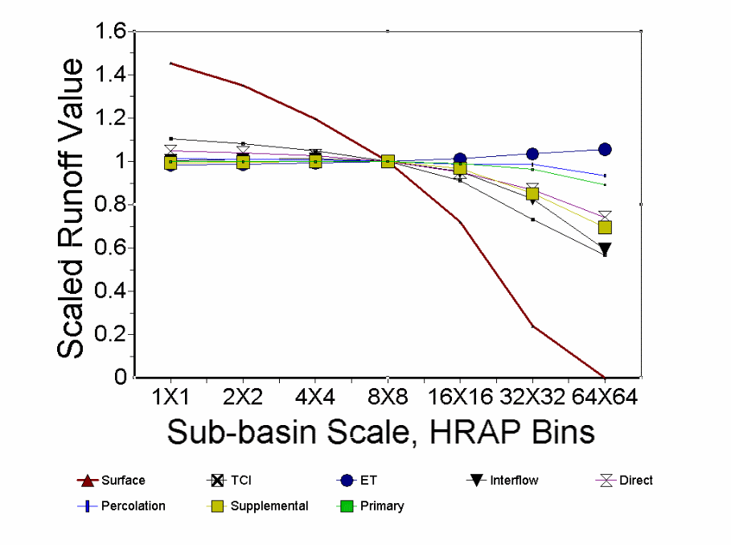

Figure 5. Relative sensitivity of SAC-SMA runoff components to size of computational area, keeping model parameters constant. Runoff values are normalized by the value at the 8x8 HRAP bin scale. (Source: Finnerty et al., 1997)

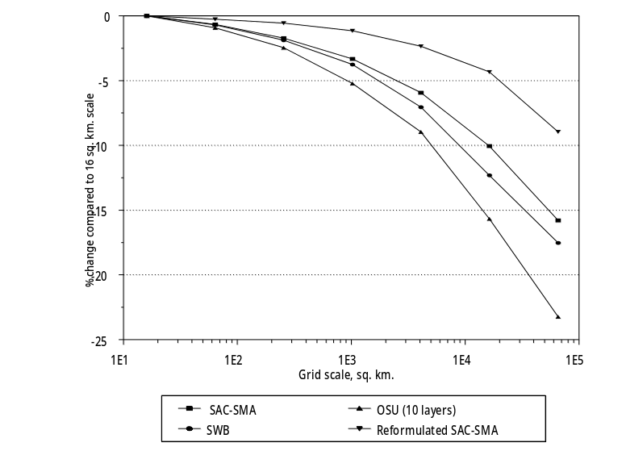

Fgure 6. Scale dependency of total runoff, simulated by different models, and expressed in percent change in surface runoff as compared to the finest scale value. (Source: Fig 4 of Koren et al., 1999; Figure 2-15 of Smith et al. 1999- NWS 44: Distributed Modeling: Phase 1 Results

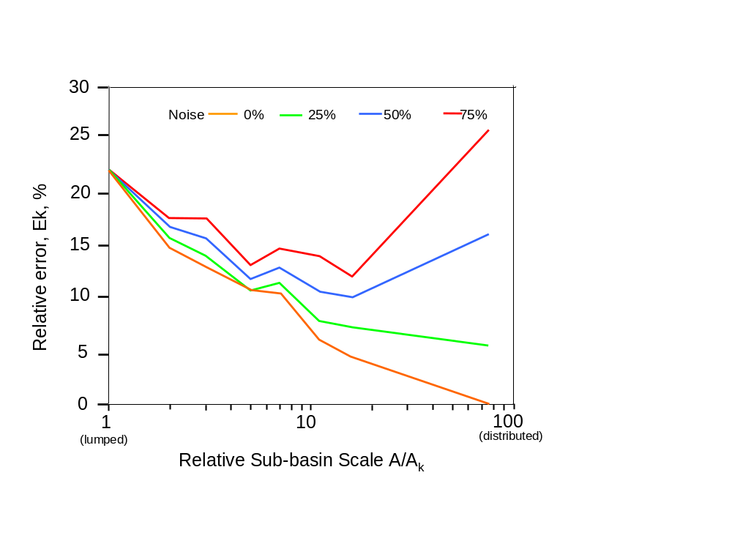
Figure 7. Relative simulation improvement versus level of sub-basin scale (disaggreation) for various degrees of noise in input forcing. (Source: Koren et al., 2003)

Tools and Models Developed in Phase 1

Practical tools and guidelines for using NEXRAD precipitation estimates were developed in Phase 1 R&D that were made available to the NWS River Forecast Centers. Table 1 presents a summary of these tools.

Table 1. Tools, Procedures, and Guidelines developed from Phase 1 R&D.

Name | Description | Status
Muskingum-Cunge channel routing | Routing algorithm compatible with current NWSRFS structure | Development version incorporated into NWSRFS, used for semi-distributed modeling (Smith et al. 2000), user documentation being written, used in NWS training workshop for routing (Sept. 2002)
Procedures for synthetic unit hydrograph development | UHG development guidelines for 1 hour lumped and semi-distribued modeling | Being revised according to Phase 2 research
Reformulated SAC-SMA model | Modified SAC-SMA model compatible with current NWSRFS structure | Incorporated into existing NWSRFS structure. Parameter calibration needs to be finalized.
Mean Areal Precipitation from NEXRAD preprocessor | Stand alone program to compute time series of mean-areal precipitation from NEXRAD data for model calibration. | Delivered to RFCs as an officially supported NWSRFS component
Guidance for calibration with NEXRAD | Description of implications of calibrating with 6 hour rain gage data the forecasting using hourly NEXRAD gridded data. | Delivered to RFCs as part of NWS technical report (Smith et al., 1999b). Taught at NWS calibration workshops.

Phase 1 Associated Collaborative Research

While conducting Phase 1 R&D, HL also collaborated with leading institutions. HL provided modest financial support to MIT in their development of a complex physically-based distributed model using a triangulated irregular network (TIN) as the computational domain. MIT’s model represents the ‘state-of-the-art’ of the class of physically based, high resolution distributed models. HL highly values the work of MIT because their modeling strategy helps address a very important question for the NWS: what level of model complexity is necessary to achieve improvements in river and flash flood simulation and forecasting? Also, HL supported the Hydrologic Research Center (HRC). Under the direction of Konstantine Georgakakos, HRC developed a distributed model using the SAC-SMA model and kinematic routing. Monte Carlo analyses with this model considered the effects of parametric and radar rainfall uncertainty. These detailed analyses supported HL’s findings that for some basins, semi-distributed models may not provide improvement over lumped models given uncertainty in model parameters and NEXRAD forcing (Carpenter et al., 2001; Carpenter et al., 1999). HL also collaborated with the University of Arizona to develop automatic procedures for the calibration of lumped and semi-distributed models. This work culminated with the work of Boyle et al. (2001), and U. of Arizona’s participation in the DMIP project (Khodatalab et al., 2004). Hogue et al.(2000) also developed a multi-step automatic calibration procedure designed to combine the power of automatic search algorithms with the insights of manual calibration.

Phase 2 Research and Development

Building on the experience gained in Phase 1, HL embarked on an aggressive campaign to develop a distributed parameter hydrologic model for NWS river and flash flood forecasting. This effort was fueled by the hiring of several key PhD-level researchers.

Phase 2 Scope

Phase 2 R&D is aimed at a very broad scope of topics that are recognized in the distributed modeling research and operational community: proper model structure, rainfall-runoff partitioning, streamflow routing, analysis of forcings, determination of optimum scale, parameterization, calibration, updating, and issues of conceptual versus so-called ‘physically-based’ modeling.

Phase 2 Goals

The NOAA NWS/OHD identified the following goals of Phase 2 R& D:

- Investigate the utility of distributed parameters and distributed forcings (in contrast to Phase 1, which focused only on distributed inputs).
- Develop prototype version of a distributed model for real time forecasting.

HL identifies the following performance parameters for a distributed model:

a. The distributed model should perform at least as well in an overall sense as the current operational lumped model. Simulation improvement should be achieved in cases of non-uniform rainfall patterns.
b. The distributed model should be operationally feasible in current and anticipated computational environments.
c. The distributed model should have procedures for parameterizaion, calibration, and state updating.

Phase 2 Constraints

In this phase, HL faces the anticipated and traditional constraint of computational limitations imposed by computer processing speeds and software architecture. Recall that the current NWSRFS cannot currently support gridded distributed modeling. HL scientists nonetheless embarked on the development of a distributed model in the expectation that a major software engineering effort would be directed towards making the distributed model operationally viable as part of the officially-released NWSRFS. Indeed, in September, 2002, an effort named Distributed Modeling System (DMS) 1.0 was launched. This software engineering project is designed to implement the HL-RMS model as an officially-supported NWSRFS component. This effort is described more fully in section 8.
I

Phase 2 R&D Strategy

Phase 2 R&D builds upon the knowledge gained in Phase 1. In this second phase, the broader question of distributed parameters was added to the investigation whereas only distributed inputs were investigated in Phase 1. While HL could have selected any one (or more) of the existing distributed models for testing, it was not clear from the literature which would be the best in light of the NOAA NWS forecasting mission. HL did not want to solely develop its own model in a vacuum, only to find that after significant time it would not be the best for RFC river and flash flood forecasting. Therefore, within Phase II, two concurrent major thrusts were launched to maximize HL’s resources and to capitalize on the considerable research performed at leading institutions:

- internal HL development of a distributed modeling system
- extensive evaluation/comparison of distributed models from leading institutions. This effort is called the Distributed Model Intercomparison Project (DMIP)

The following rationale shows the concurrent and interwoven parts of this research strategy:

- HL develops a research modeling system, (HL-RMS) capable of testing model components at different scales (lumped, semi-distributed, gridded distributed). This system is modular, so that as the DMIP results appear, HL would be ready to test algorithms and components that are deemed beneficial. HL develops the NWS’s first distributed model within HL-RMS.

- HL leads DMIP to identify models and or components that appear advantageous for NWS river and flash flood forecasting. DMIP was also envisioned as a vehicle to identify institutions for continued collaborative research.

- HL participates in DMIP. HL generates simulations as an official DMIP participant. In this way, HL not only leads DMIP, but is a major contributor as well.

Internal HL Distributed Model Development

HL has developed the Hydrology Laboratory Research Modeling System (HL-RMS). This modeling system combines lumped conceptual and distributed model features. This formulation is meant to capitalize on HL’s considerable understanding of and experience with the SAC-SMA model. Moreover, this model philosophy was designed to address the concern of Robinson and Sivapalan (1995), who stated that not enough analyses are being performed to explore the connections between physically-based and conceptual models, even though they stated this is ‘precisely what is required for the advancement of hydrological modeling for predictive purposes’.
Koren et al. (2003, 2004) describe the details of HL-RMS. However, a brief overview of HL-RMS is warranted here.
HL-RMS is a flexible modeling system, able to use grid cells or sub-basins as the computational elements for rainfall-runoff modeling. Currently, HL-RMS is defined on a regular rectangular grid as shown in Figure 8. Each grid cell consists of a water balance component and a hillslope and channel routing component. A number of conceptual hillslopes are defined to make overland flow distances physically realistic for the relatively large (~ 16 km²) cell size. A drainage density parameter is used to subdivide a cell into equally sized overland flow planes as seen in Figure 8. Conceptual hillslopes drain water to a conceptual channel within the same grid cell. A conceptual channel usually represents the highest order stream of a selected grid cell. It is assumed that all hillslopes have the same properties inside each grid cell but they may be different from cell to cell. The main channel length within each cell is assumed to be equal to the cell diagonal distance. Cell-to-cell channel routing is done using a flow direction grid like that illustrated in Figure 8. A modified version of the algorithm described by Wang et al. (2000) was developed to generate the flow direction grid. The algorithm automatically generates a coarser resolution flow direction grid from higher resolution DEM data. As a result, the basin boundaries and channel structure match reasonably well with high resolution basin properties (see Figure 8). To facilitate efficient routing calculations, the drainage network depicted in Figure 8 is translated into a computational sequence of grid cells in an upstream to downstream order. The same method for storing the computational grid sequence was used in the Nile Forecast System (Koren and Barrett, 1995).
Each grid cell consists of a water balance component and a hillslope and channel routing component. Fast response runoff from the water balance model is routed over conceptual hillslopes within each cell to a conceptual channel. Slow response runoff is assumed to enter the channel system directly from the soil and therefore bypass the hillslope routing. There is no physical connection between soil moisture states in adjacent grid cells. The conceptual channel is the only source of water exchange between neighboring pixels. While this may be considered a weakness in the current distributed system, some field data support this ‘zero lateral conductivity’ assumption (Watson et al., 1998).
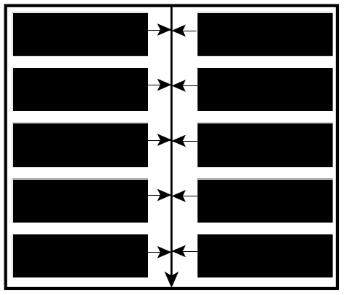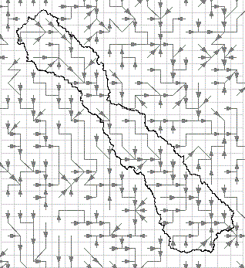
(a)
(b)
Figure 8. HL-RMS treatment of computed flows. A. Cell flow directions and connectivity for the Blue River basin in Oklahoma. Drainage area is 476 sq. mi. B. Conceptual representation of overland flow segments feeding a single channel in each HL-RMS computational cell.

The water balance component of the current version of the HL-RMS first used the Sacramento Soil Moisture Accounting Model (SAC-SMA). Recently, the Continuous Antecedent Precipitation Index (API) model was added specifically for the domain of the Mid-Atlantic River Forecast Center (MARFC). In all cases, the hillslope-channel routing component employs the kinematic wave model. Several factors played a role in the selection of the SAC-SMA model. Use of the SAC-SMA is a practical choice because NWS hydrologists have great experience with lumped applications of the model. Also, the work of Koren et al. (2000) established relationships between SAC-SMA parameters and soil properties, making it possible to run simulations using parameter estimates that vary within a basin. The kinematic wave model is well tested, and it is successfully used in watershed modeling (Goodrich et al., 1991; Willgoose and Kuczera, 1995; Koren and Barrett, 1995; Georgakakos, 2002; Vieux and Moreda, 2003). Although the accuracy of the kinematic model is reduced in hydraulically mild slopes (Fread, 1993; Singh, 1996), it is appropriate to use it in the first version of the HL-RMS mainly for two reasons: (1) it will be used mostly for headwater basins where lateral inflow effects dominate over wave propagation effects, and (2) flood prediction (the main goal of the HL-RMS) is most critical in regions of rather steep topography regions (e.g., dominant slopes in basins studied here were well above 0.005). Another consideration was high computational efficiency and flexibility of this algorithm as it followed from its application to the Nile basin (Koren and Barrett, 1995). We anticipate that in operational applications over large river basins the HL-RMS will be combined with a dynamic routing model which is now available in the NWS River Forecasting System.

HL-RMS parameterization using DEM-GIS data

Water balance and routing model parameters are assumed to be constant within each grid cell, however, they can vary from cell to cell. Thus, spatially variable parameter grids should be generated over the area of interest. As shown in Figure 9, the approach adopted in HL-RMS is a two step procedure: derivation of a priori parameter grids, and adjusting of these grids using observed outlet hydrographs. Derivation of a priori parameter grids is a critical step to guarantee the success from a parameter adjusting step based on a basin response. Rinaldo et al. (1995) found that the inverse procedure of obtaining the local basin properties (in their case basin width function) from the basin response is not reliable. Therefore, reasonable spatial parameter patterns should be defined independently from basin properties. The basic idea used in this study is to combine distributed grid cell data (e.g. slope, soil properties) with integrated basin properties observed at the outlet (e.g. rating curve data). While this idea was applied in the first step of the routing parameter estimation procedure, it was used only in the second step of water balance model parameterization.

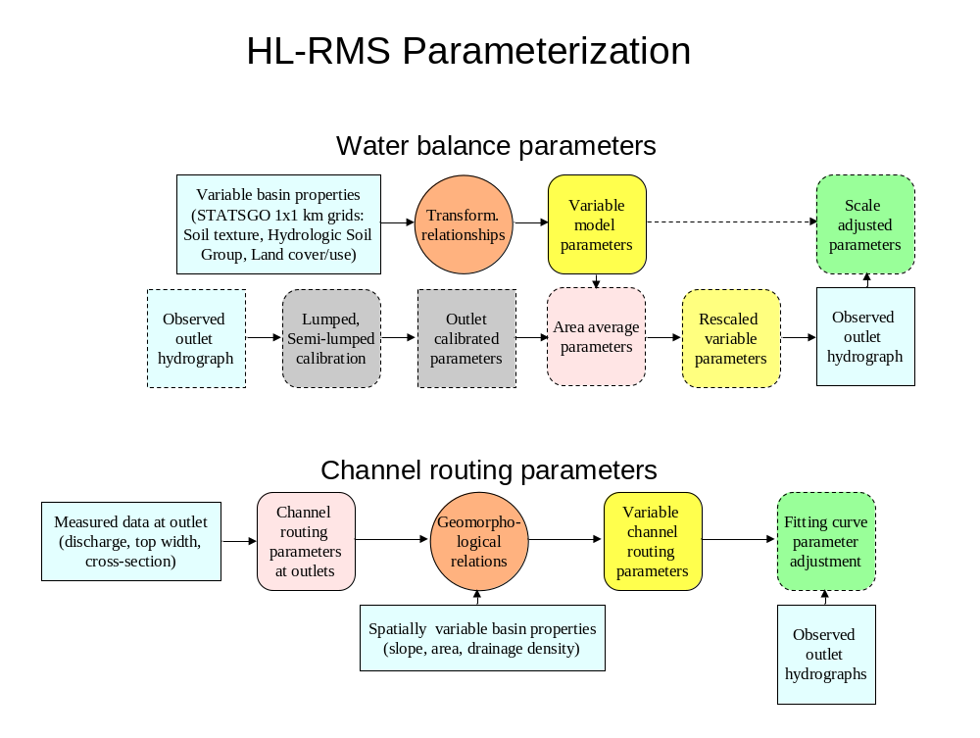
Figure 9. Schematic for parameterizing the water balance and channel routing components of HL-RMS

Estimation of SAC-SMA parameters

Although there are strong physical arguments to support the SAC-SMA model, its 16 parameters cannot be measured directly. Manual and automatic procedures to estimate SAC-SMA parameters for lumped model applications are well defined (Burnash, 1995; Smith et al., 2003; Boyle et al., 2000; Hogue et al., 2000). The procedures are based solely on input-output data analysis. Consequently, they do not provide any information on intra-basin parameter variability, which is desirable information for the implementation of a distributed model. To account for the spatial variability within basins, a priori SAC-SMA parameter grids developed by Koren et al. (2000) were used.
Koren et al. (2000) pioneered a set of equations to derive 11 major SAC-SMA parameters from soil texture, hydrological soil group, and soil depth. (This work was later reported on by Duan et al., 2001). These equations were developed based on both physical reasoning and empirical relationships. The main assumption was that tension water storages of the SAC-SMA model were related to available soil water (difference between field capacity and wilting point), and that free water storages were related to gravitational soil water. Available soil water and gravitational soil water were derived from soil properties which could be inferred from soil texture: porosity, field capacity, wilting point, and hydraulic conductivity. Using 1-km soil texture data estimated for 11 soil layers (Miller and White, 1999), Koren et al. (2000) generated a priori SAC-SMA parameter grids covering the conterminous United States. These have been made available to the NWS RFCs via the Calibration Assistance Program (CAP). An example of the parameter grids is shown in Figure 10, which shows the value of the SAC-SMA upper zone tension water depth for the entire Nation.
Results from lumped simulations using basin-averaged a priori parameters (Koren et al., 2000; Duan et al., 2001; Koren et al., 2002) suggest that while a priori estimates cannot outperform results from well calibrated parameters on gaged basins, their values are reasonable initial estimates for manual or automatic calibrations.
Koren et al. (2003) discussed the limitations of the SAC-SMA parameters derived from the STATSGO data. To address these limitations, research is underway in HL to adapt the theory developed by Koren et al. (2000) to use the high resolution county-level NRCS SSURGO data (Anderson, et al., 2003).
As with other distributed hydrologic models, significant effort is needed to develop advanced parameter calibration techniques for HL-RMS. Work is currently underway to investigate automatic calibration strategies for use with the SAC-SMA parameters in HL-RMS. A newly-developed simplified search algorithm called Step-Wise Line Search (SLS) combined with the a priori parameters of Koren et al. (2000) has shown to achieve parameter sets equivalent to those derived from the Shuffled Complex Evolution (SCE) developed by Duan et al. (1993). However, this new approach requires far fewer function evaluations than the SCE algorithm. For example, the SLS procedure requires only hundreds of function evaluations to optimize 11of the SAC-SMA parameters in a lumped application, whereas SCE needs upwards of 10,000 evaluations to achieve the global optimum solution. Given the efficiency of this approach for lumped basins, it is hoped that the SLS procedure can be applied to the simultaneous optimization of the SAC-SMA parameters in the dozens of computational elements in a typical application of HL-RMS. SCE would simply be too computationally intensive in a distributed model application.

Estimation of routing parameters using DEM and channel hydraulic data

Hillslope routing parameters. Three parameters are defined for overland flow routing: hillslope slope, roughness, and drainage density (or hillslope length if available). Note that in current model structure, hillslope slope and roughness may vary from cell to cell, but not among the conceptual hillslopes within a cell. Representative hillslope slopes are estimated from DEM data (30-m DEM data for basin scale applications, and 400-m DEM data for regional scale applications) by first computing the local slope of each DEM cell in the study domain, and then averaging all of the DEM cell slopes in each model cell (Reed et al., 2002). Spatially variable hillslope roughness values can be related to land use data based on a lookup table (e.g., Skahill and Johnson, 1999). However, a lookup table is very subjective, and it offers limited guidance in defining spatial variability because within a given land use category, published roughness values cover wide ranges of possible values that often overlap with the ranges assigned to other land use categories. Initial HL-RMS tests have shown more sensitivity to channel routing parameters than hillslope parameters; the tests also suggest that using spatially consistent hillslope roughness has been satisfactory. Therefore, a constant value of hillslope roughness (0.15) has been assigned for all model cells in the current HL-RMS implementation.
For drainage density, Dingman (1993) notes that values ranging from 2 km⁻¹ to 100 km⁻¹ have been reported in the literature, and that drainage density varies depending on climate and geology. For areas we are modeling in the dry Southern Great Plains region of the United States, a spatially constant value of drainage density (2.5 km⁻¹) has been assumed.
Current work in HL involves the addition of a Muskingum-Cunge routing algorithm for HL-RMS application in flatter-sloped basins. Future ideas include the linking of HL-RMS with a full dynamic wave channel routing algorithm.

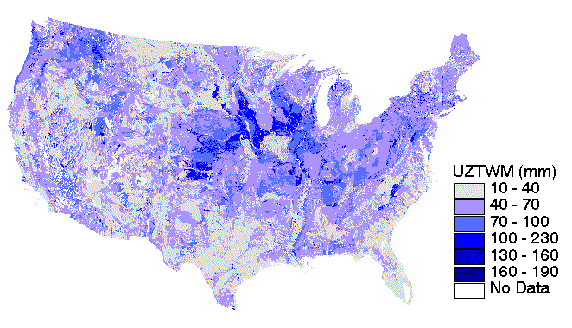

Figure 10. A priori estimates of the SAC-SMA model upper zone tension water depth in mm for the CONUS domain. Cell resolution is 1km²

Large Area applications of HL-RMS

We believe that a valid development component for distributed modeling for river and flash flood forecasting and water resources modeling is to execute a large area or CONUS implementation of HL-RMS. This strategy is meant to mimic the development path of numerical weather prediction models. Early in their history, these models were established to run on a CONUS domain. Such an implementation attracted numerous researchers who contributed new components or algorithmic improvements. In this large-area application, real time precipitation and temperature data feeds into HL would be established so that the HL-RMS could be executed each day at an hourly time step. To date, a large area application has been launched that covers the Arkansas River basin in the domain of the Arkansas-Red Basin River Forecast Center (ABRFC) as shown in Figure 11. In this application, HL-RMS was executed over 25,000 computational elements (4km²). Figure 12 shows more of the details of the implementation: (a) spatial variability of one of the SAC-SMA parameters, (b) input precipitation, (c) one of the SAC-SMA states, (d) HL-RMS computed flow. A test of this application revealed that a 10-day simulation executing at an hourly time step took just under 5 minutes on an HP workstation. Thus, recent exponential advances in computer processing speeds and storage capabilities have largely removed the traditional computational barriers to operational distributed modeling. Figure 13 shows the good agreement between the observed and simulated flows for the Arkansas River.

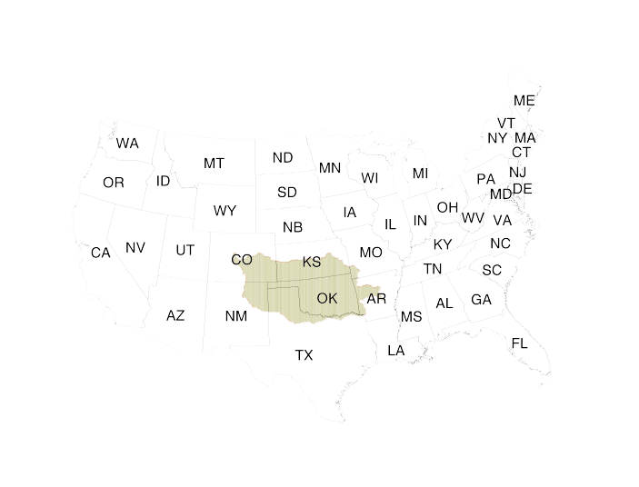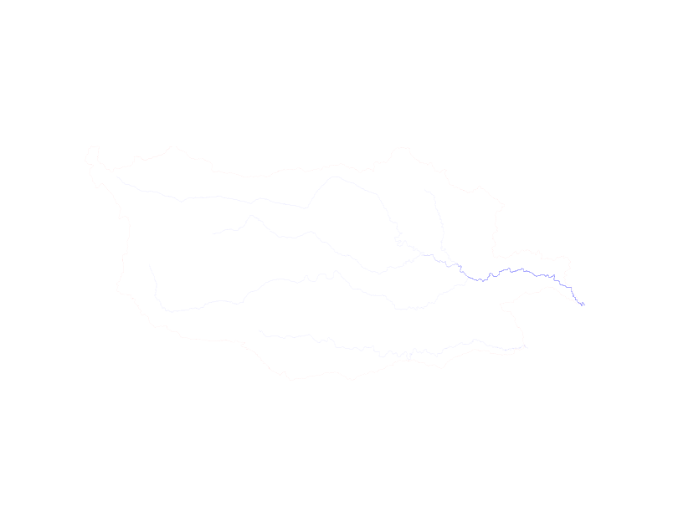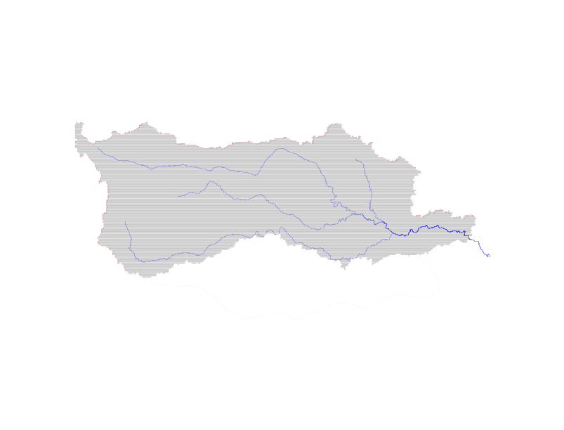
ABRFC
Large Area Application
of HL Distributed Model
outlet
25,000
computational
elements

Figure 11 Large-area implementation of HL-RMS over the Arkansas River basin.

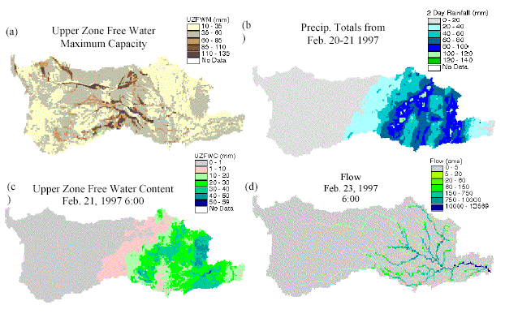
Figure 12. Observed and derived fields from the large-area application of HL-RMS.
(a) Value of the SAC-SMA parameter for the upper zone free water reservoir; (b) NEXRAD precipitation for an event in February, 1997. (c) Amount of computed water in SAC-SMA upper zone free water reservoir; (d) Compute channel flow. (Source: Reed et al., 2002)

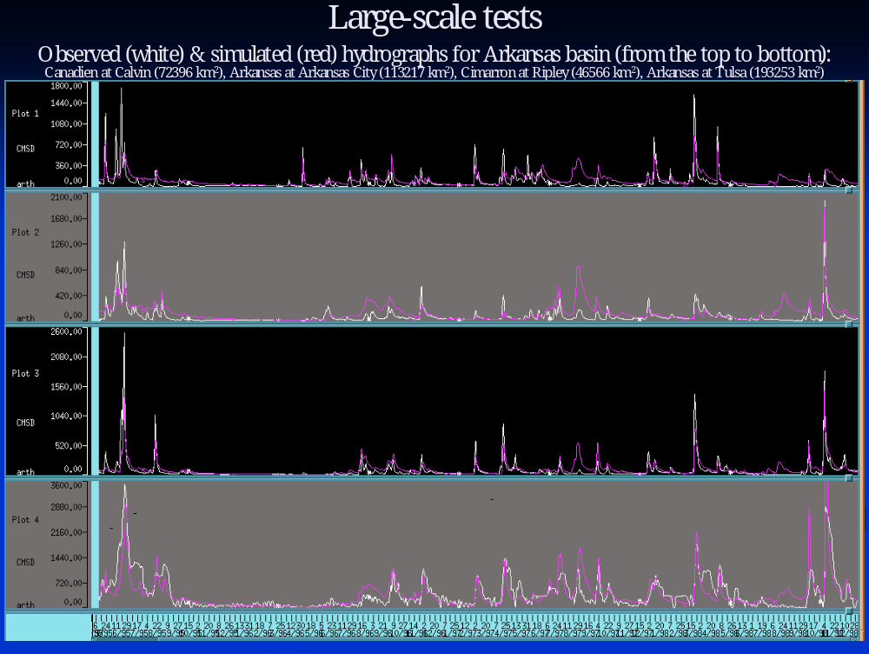
Figure 13. Large-Area Application of HL-RMS: Initial discharge simulation of the entire Arkansas River Basin

Prototype Application of HL-RMS

Development and testing of HL-RMS has progressed to the point that operational testing at several RFCs would provide valuable insight into its performance. Four RFCs volunteered to implement prototype versions of HL-RMS: ABRFC, WGRFC, CBRFC, and MARFC shown in Figure 14. (Note: here, we use the term ‘prototype’ to signify that it has not been officially released as part of NWSRFS software builds). In ABRFC, WGRFC, and CBRFC, HL-RMS is being run on individual NWS forecast basins. In MARFC, HL-RMS is being implemented over the entire Juniata River basin as shown in Figure 15. In several ways, the MARFC prototype application is spearheading HL-RMS development. First, a continuous antecedent precipitation index (API) model has been incorporated into HL-RMS for use in this area to match the model used operationally by the RFC. Research and development for this effort has led to a strategy to define the API model parameters from GIS-based soils information (Moreda et al., 2003). The inclusion of another model into HL-RMS (in addition to the SAC-SMA) has proven the robustness and modularity of the HL-RMS design. Second, the operational NWS snow model developed by Eric Anderson (1968) has also been incorporated into HL-RMS for this application. Initial tests of this version of HL-RMS have shown that this version of HL-RMS is computationally correct and robust Much work remains, however, in the parameterization and calibration of distributed API and snow models.

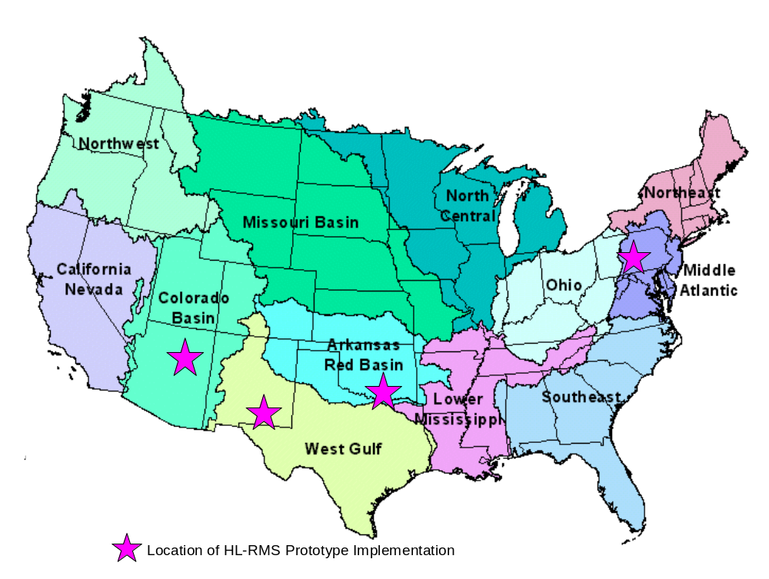
Figure 14. Location Map of Sites for HL-RMS Prototype Implementation. Colored areas are the domain extents of the NWS River Forecast Centers.

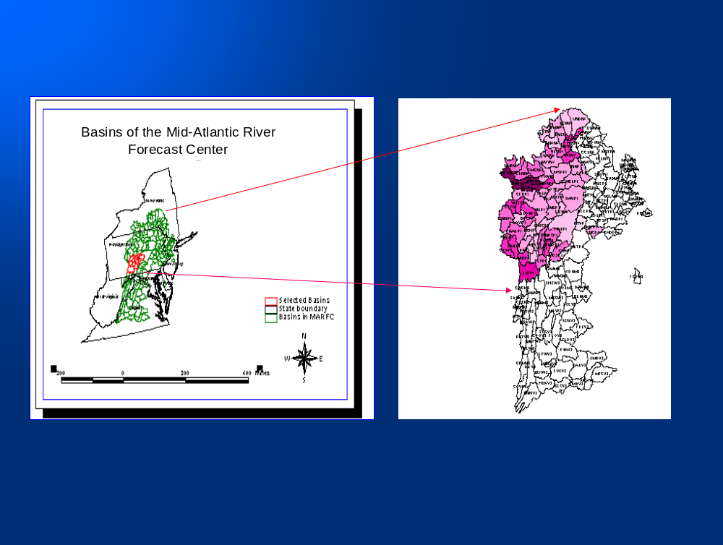
Figure 15. Location of the Susquehanna River and its sub-basins for prototype implementation of HL-RMS.

The Distributed Model Intercomparison Project (DMIP)

Background for DMIP

Concurrent with the in-house development of HL-RMS, HL also initiated DMIP (Smith et al., 2004a) (see also http://www.nws.noaa.gov/oh/hrl/dmip/index.html). This effort arose out of the convergence of several factors. First, NOAA NWS realized the need to infuse new science into its river forecasting capability. Second, the continued proliferation of geographic information system (GIS) data sets and exponential increases in computer capabilities have largely removed historical barriers from the path for development of complex distributed models. Finally, but certainly not the least important, large questions remain in the scientific literature regarding the effect of the variability of precipitation and basin properties on runoff response. Related to these questions is the choice of model or approach to best exploit variability information to generate improved outlet simulations and potentially useful information at ungaged interior points.
Given the scale of the NWS mission and the recommendations from external reviewers, it was clear that an accelerated program was needed to move the NWS research in the proper direction for operational distributed modeling. While numerous distributed models exist and indeed some are moving into the operational forecasting environment (e.g., Koren and Barrett, 1994; Turcotte et al., 2003) it is not clear from the literature which distributed model or modeling approach is best suited to improve the NWS forecasting capabilities. With guidance from several outside organizations, the NWS formulated DMIP as a method to capitalize on the formidable distributed modeling research being conducted at academic institutions and other organizations around the world. DMIP can also be considered as an extension to the model comparison research being performed in a joint collaborative research effort between MIT and HL.
With the advent of 4km spatial resolution Next Generation Radar (NEXRAD) rainfall estimates in many parts of the US, the NWS and the research community at large have access to gridded rainfall estimates at unprecedented spatial and temporal resolution. Other parts of the world have similar quality radar data available (e.g., Moore and Hall, 2000). Also, the proliferation of GIS data sets and ever-increasing capabilities of computer systems have continued to push distributed modeling to the forefront of hydrologic research and application. In light of these developments, the major question facing the NWS and perhaps other operational organizations is: what is the best way to exploit the information in high resolution radar rainfall estimates and GIS data sets to improve river and flash flood forecasting? Or, in the words of Beven (1985), under what conditions and for what type of forecasting is it profitable to implement a distributed model?
A review of the scientific literature did not provide clear guidance for the NOAA NWS. A comprehensive comparison of lumped and distributed modeling techniques has not been published. It is encouraging that in the development and testing of their distributed models, several authors have included a comparison of their results to those using lumped inputs or from simpler lumped approaches (Bell and Moore, 2001; Boyle et al., 2001; Smith et al., 1999; Michaud and Sorooshian, 1994b; Obled et al., 1994; Pessoa et al., 1993; Naden, 1992; Loague and Freeze, 1985). In addition, Carpenter et al., (2001) used Monte-Carlo analysis to evaluate distributed versus lumped model gains in light of parametric and radar rainfall data uncertainty.
However, HL felt that a more organized and controlled comparative effort is required to guide NWS distributed modeling research and development. The emergence of high resolution data sets, GIS capabilities, and rapidly increasing computer power has maintained distributed modeling as an active area of research. While the utility of distributed models to predict interior hydrologic processes is well known, few studies have specifically addressed the improvement of distributed models over lumped models for predicting basin outflow hydrographs of the type useful for flood forecasting. As a consequence, the hypothesis that distributed modeling using higher resolution data will lead to more accurate outlet hydrograph simulations remains largely untested.

DMIP Schedule

HL guided DMIP according to the schedule in Table 2. An initial science plan was developed in HL then sent to many institutions for comment. Data were collected from contributors and HL archives and placed on an ftp site. DMIP was officially launched with a town-hall meeting at the Spring Meeting of the AGU in Washington, DC on May 31, 2000. While follow-on research continues, this first phase of DMIP culminated in the publication of a special issue of the Journal of Hydrology to be released in the spring of 2004.

Table 2 Schedule for Major DMIP Activities

Date | Task
January, 2000 | Basic DMIP plan approved by NWS/HL
May 31, 2000 | General Announcement of DMIP at Town Hall Meeting, AGU spring Meeting, Washington, DC
June 1, 2000 | DMIP plan completed
December 2000 | General Announcement to participate in DMIP  DMIP web site officially opened.
January 1, 2001 | 1. All data in place for Illinois River Basins, Elk River Basin and Blue River Basin  2. Metadata and utilities in place
March 31, 2002 | Participants send results to HL for analysis
August 22-23, 2002 | DMIP summary workshop at NWS/HL with all participants
September 30, 2002 | Participants verify that analyzed simulations are correct
January 31, 2003 | Deadline for any follow-up submissions.
Spring, 2004 | Publication of J. Hydrology DMIP Special Issue

DMIP Study Area

The DMIP study basins in Figure 16 were selected for several reasons. First, these basins had the data required to conduct the intercomparison, beginning with the longest and highest quality archive of NEXRAD radar-based precipitation estimates in the U.S. The NWS began measuring precipitation with NEXRAD radars in this region in 1993, providing the DMIP project with nearly 8 years of continuous hourly gridded precipitation estimates. The NEXRAD radars in this area provide good coverage of the study basins as shown in Figure 2. Also, several pertinent studies of the quality of the NEXRAD precipitation estimates in this region have been performed. (e.g., Young et al., 2000; Wang et al., 2000; Smith et al., 1999; Johnson et al., 1999; Finnerty and Johnson, 1997; and Smith et al.,1996). Concurrent time series of hourly discharge data were also available for the basin outlets and selected interior points.
Another critical criterion for selecting basins in this region is the lack of complications such as significant snow accumulation, orographic influences, and modification of the streamflow due to reservoirs. Moreover, the selected parent basins contain several internal points having observed streamflow data, allowing the DMIP program to develop study questions regarding the prediction of interior hydrologic processes.
The Illinois River flowing through Arkansas and Oklahoma presented a good opportunity for participants to test their models on nested basins as seen in Figure 16. The Eldon basin has an interior gage on Peacheater Creek at Christie, OK. Next to the Eldon basin is the Watts basin, which contains the catchment draining to the USGS gage at Savoy, AR. Both the Watts and Kansas basins are nested within the largest basin, the Illinois River above Tahlequah, OK. Thus, the Tahlequah basin contains three interior gage locations.

DMIP Participants

The following institutions and lead investigators participated in DMIP:

1. Massachusetts Institute of Technology, Dr. Rafael Bras
2. Hydrologic Research Center, Dr. Konstantine Georgakakos
3. DHI Water and Environment, Dr. Michael Butts
4. University of Arizona, Dr. Hoshin Gupta
5. NCEP/EMC, Dr. Kenneth Mitchel, Dr. Dag Lohman, Dr. Christa Peters-Lidard
6. University of Oklahoma, Dr. Baxter Vieux
7. University of Waterloo, Ontario, Dr. Allyson Bingeman
8. University of Utah, Dr. David Tarboton and National Institute of Water Research, (NIWR), New Zealand, Dr. Ross Woods.
9. NWS Hydrology Lab, Dr. Mike Smith
10. USDA ARS, Dr. Jeff Arnold and TAES Blackland Research Center, Dr. Mauro Di Luzio
11. University of California at Berkeley, Dr. Xu Liang
12. The Hydraulic and Electrical College of WuHan University, China, Dr. Li Lan

All participants followed the DMIP modeling instructions and submitted simulations to HL for analysis. In August, 2002, HL hosted a three-day meeting of all participants and presented extensive analyses of the results.
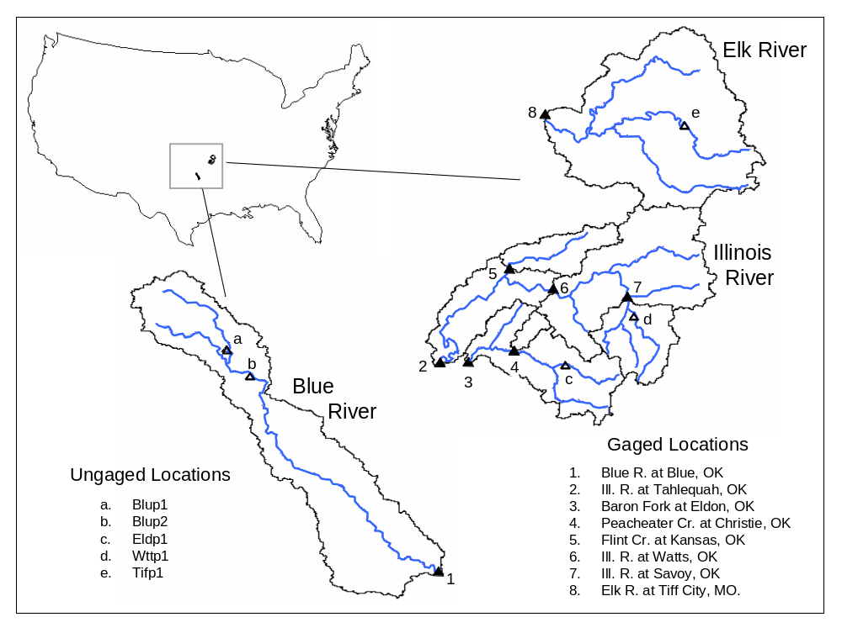
Figure 16 Study basins used in DMIP (source: Smith et al., 2004a)

Major Findings from DMIP

HL scientists concluded from the DMIP results that both the HL-RMS and our proposed research path were scientifically sound and that no major changes need to be made at the present time. However, HL is committed to evaluating new rainfall-runoff and routing models in order to improve its services to the Nation. The following major DMIP conclusions are taken from Reed et al. (2004):

- Although the lumped model outperformed distributed models in more cases than distributed models outperformed the lumped model, some calibrated distributed models can perform at a level comparable to or better than a calibrated lumped model (the current operational standard). The wide range of accuracies among model results suggest that factors such as model formulation, parameterization, and the skill of the modeler can have a bigger impact on simulation accuracy than simply whether or not the model is lumped or distributed.

- Clear gains in distributed model performance can be achieved through some type of model calibration. On average, calibrated models outperformed uncalibrated models during both the calibration and validation periods.

- Gains in predicting peak flows for calibrated models were most noticeable in the Blue and Christie basins as shown in Figure 17. The Blue basin has shape, orientation, and soil characteristics that are distinguishable from other basins in the study. The Blue results are consistent with those of previous studies and indicate that the gains from applying a distributed simulation model at NWS forecast basin scales (on the order of 1000 km2) will depend on the basin characteristics. Christie is distinguishable in this study because of its small size.

- The Christie basin had distinguishable results from the larger basins studied, not just in overall statistics, but in relative inter-model performance compared with larger basins. One explanation offered for the improved calibrated, peak flow results is that the lumped “calibrated” model parameters (from the parent basin calibration, Eldon) are scale dependent and distributed model parameters that account for spatial variability within Eldon are less scale dependent. Some caution is advised in interpreting the results for Christie for model submissions with a relatively coarse cell resolution compared to the size of the basin. Since no other basins in DMIP are comparable in size to Christie, more studies on small, nested basins are needed to confirm and better understand these results.

- Among calibrated results, models that combine techniques of conceptual rainfall-runoff and physically-based distributed routing consistently showed the best performance in all but the smallest basin. Gains from calibration indicate that determining reasonable a priori parameters directly from physical characteristics of a watershed is generally a more difficult problem than defining reasonable parameters for a conceptual lumped model through calibration.

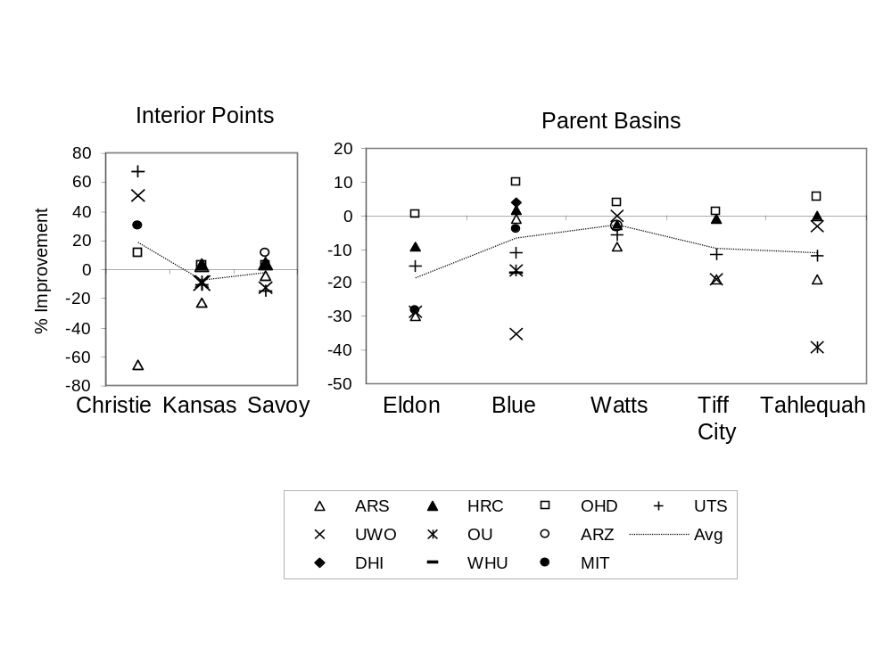
Figure 17. Improvement of Distributed Model over Lumped SAC-SMA for different DMIP basins and models. Results are for calibrated lumped and distributed models. The basins are segregated into parent basins and interior computational points. Positive values of improvement indicate the distributed model performed better than the NWS calibrated lumped SAC-SMA model

- Simulations for smaller interior basins where no explicit calibration was done exhibited reasonable performance in many cases, although not as good statistically as results for larger, parent basins. The relatively degraded performance in smaller basins occurred both in cases when parent basins were calibrated and when they were uncalibrated, so the degraded performance was not simply a function of the fact that no explicit calibration at interior points was allowed.

- Distributed models designed for research can be applied successfully using operational quality data. Several models responded similarly to long term biases in archived multi-sensor precipitation grids. Ease of implementation could not be measured directly. However, an indirect indicator of operational practicability is that several participants were able to submit a full set or nearly a full set of simulations in a relatively short time.

In addition, DMIP follow-on research in HL investigated the identification of basins that will benefit from distributed models for basin-outlet simulations. Smith et al. (2004b) and Zhang et al. (2004b) explored time series analysis techniques to derive diagnostic indicators from concurrent time series of observed basin precipitation and discharge. They concluded that one of the basins in the DMIP suite had unique characteristics regarding the spatial variability of precipitation and the ability of a basin to filter or dampen the input precipitation signal. Figure 18 shows the relationship between the center of mass of storm precipitation (location index on abscissa) and a measure of the basin’s filtering effect (dampening ratio on ordinate). It is clear from Figure 18 that the Blue River is unique amongst the study basins by having the greatest spatial variability of precipitation while exerting the least filtering on the input rainfall signal.
Finally, Michael Smith of HL was invited by the Chief Editor Roman Krzysztofowicz of the Journal of Hydrology to be Guest Editor of a special issue of the journal dedicated to DMIP. This special issue will appear in the spring of 2004. Dr. Konstantine Georgakakos of HRC and Dr. Xu Liang of the University of California Berkeley will be co-Guest Editors. This issue will feature 14 papers from the DMIP participants.

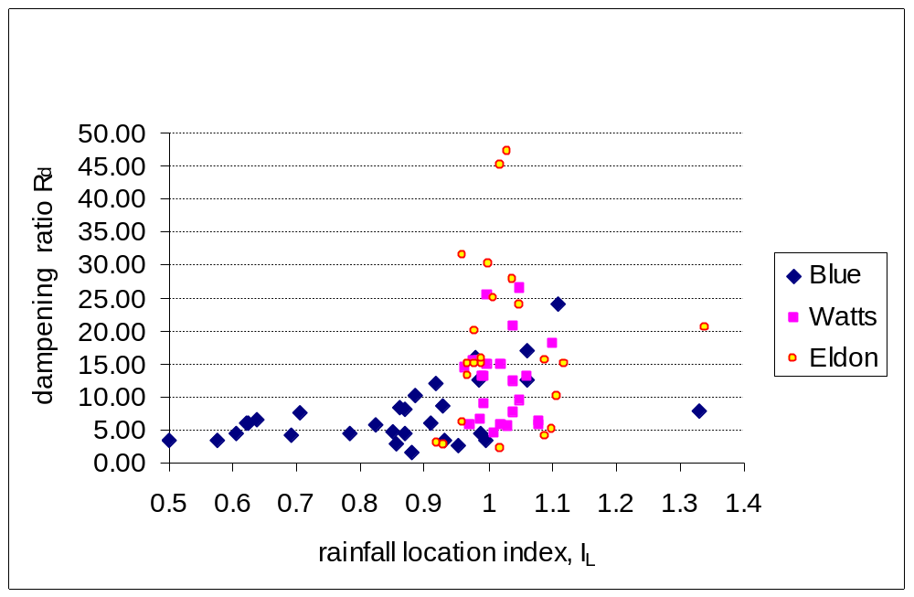
Figure 18. Relationship between storm rainfall center-of-mass (rainfall location index) and a basins ability to dampen the input rainfall signal (dampening ratio) for three DMIP basins. (Source: Smith et al. 2004b)

Future DMIP Phases

HL is now in the preliminary planning stages for a second phase of DMIP. Initial reaction from the hydrologic modeling community for another DMIP phase has been very positive. Current activities include developing the science questions to be addressed. We anticipate that DMIP II will examine complexities such as snow and orographics. At present, there is some discussion on organizing DMIP II as part of the Prediction in Ungaged Basins (PUB) initiative.

Tools and Procedures from Phase 2 R&D

As with Phase 1 R&D, Phase II has provided a steady stream of tools and other practical items delivered to the RFCs. Table 2 shows that items ranging from DEM processing tools to the full prototype version of the HL-RMS distributed model have been delivered throughout the progression of this phase.

Table 3. Tools developed and delivered as a result of Phase 2 research and development

Name | Description | Status
Prototype version of HL-RMS | HL-RMS distributed model that can be used for operational forecasting | Used by 3 RFCs on selected basins
SAC-SMA parameters | National data sets in Arc/View format of all 11 SAC-SMA parameters. | Delivered to RFCs as part of Calibration Assistance Tool
Statistics program | Stand-alone program to compute statistics from time series for model calibration | Linux version available. Ready for RFC use
Advanced tools for channel routing parameterization | Excel and MATLAB programs developed. | Excel programs delivered to RFCs involved in prototype testing.
DEM processing tools | Advanced flow direction strategy (Reed, 2003) for 4km cells | Used in HL to process DEMs for RFC useage.
Distributed Model Calibration Strategy | Strategy to transition from lumped 6hr model to hourly dist. model | Delivered to RFCs involved in prototype testing.
DMIP results | Evaluation of 12 distributed models to guide NWS R&D | Draft copies of two Journal of Hydrology papers sent to RFCs
UHG development tool | New procedure uses Variational assimilation (VAR) | Prototype delivered to several RFCs for evaluation.

Collaborative Research Associated with Phase 2 R&D

As with Phase 1, a significant emphasis is placed on extramural research and collaboration. In this phase, we extend work with our previous partners MIT, U. of Arizona, and HRC. We continue to value the work of MIT as we consider their model to represents the state-of-the-art in complex so-called ‘physically-based’ distributed models. Their model provides valuable insight into the computation of the major types of runoff including infiltration-excess and saturation excess. MIT’s work continues to help the NWS address the question of how much model complexity is warranted to achieve a certain prediction accuracy. HRC continues to examine the effects of parameter and NEXRAD rainfall uncertainty on gains realized from distributed versus lumped models. Recently they have been characterizing the uncertainty in the NEXRAD precipitation at the bin scale rather than at the scale of the sub-basin (computational element) scale. An intriguing result of this work is the identification of a relationship between basin area and simulation uncertainty (Carpenter and Georgakakos, 2004, 2003). HRC is also examining distributed modeling from an end user standpoint such as for water resource management. The University of Arizona continues to perform research into optimization schemes for lumped and distributed models and has recently requested the HL-RMS distributed model code for their research.
This year, HL intends to add a new collaborative partner for distributed modeling. The University of Minnesota proposes research into a probabilistic method for generating channel routing parameters for the kinematic wave routing component in HL-RMS.

Distributed Modeling for Flash Flood Forecasting

We propose that distributed modeling forms the most scientifically valid procedure for flash flood forecasting over a wide domain. Figures 19 and 20 illustrate our proposed strategy. First, we envision that HL-RMS would be implemented at a typical RFC forecast basin to generate standard basin-outlet forecasts. For example, Figure 19 shows that HL-RMS applied to the Blue River (drainage area 476 sq. mi.) in Oklahoma would require approximately 80 computational elements.

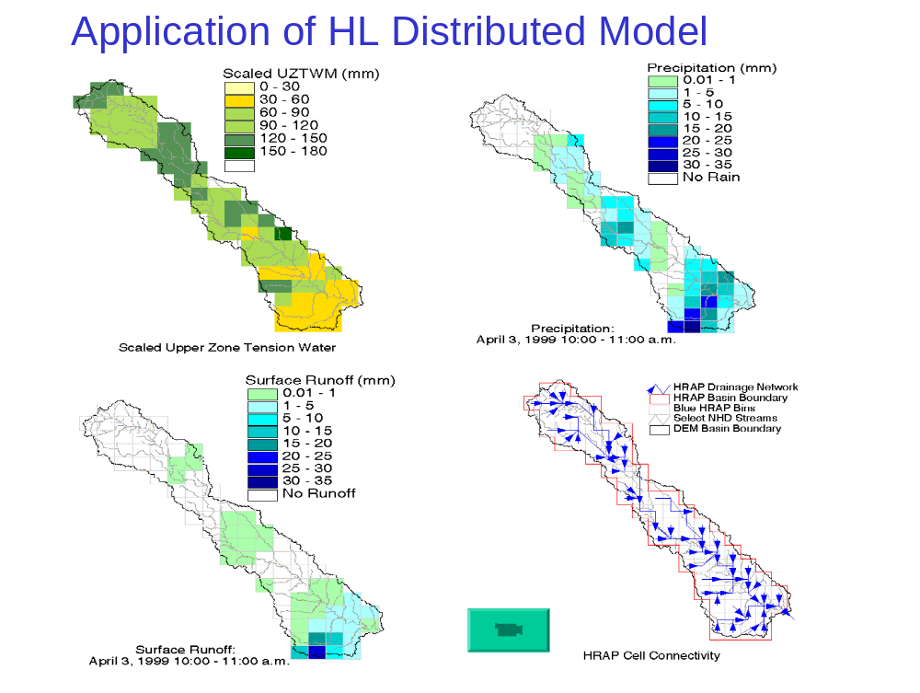
Figure 19. Application of the Distributed model HL-RMS to the Blue River, OK. Approximately 80 computational elements are used in this application.

Given that the basin is modeled as in Figure 19, it is possible to predict the hydrologic activity at any of the 80 computational cells. Thus, if rainfall is sufficiently concentrated at any point in the basin to cause alarm, the forecaster would be able to generate a forecast for that specific area. Figure 20 illustrates this idea. From Figure 19, we see that in an actual even in April, 1999, the rainfall was concentrated near the basin outlet. Such a concentration would alert a forecaster that further investigation is warranted. The forecaster could generate forecasts at points A and B in Figure 20 and determine that no significant river rise will occur. However, the response at Point C, the basin outlet, will be quite extreme. Figure 20 also clearly illustrates how a distributed model provides improved simulations compared to a lumped model in cases of non-spatially-uniform precipitation. The distributed model simulation agrees well with the observed discharge, while the lumped model has a dampened response. We anticipate using the work of Carpenter and Georgakakos (2004, 2003) to incorporate uncertainty estimates for interior simulations given parametric and NEXRAD precipitation uncertainty. They identified a relationship between basin scale and simulation uncertainty. Thus, given uncertainty defined ab basin outlets, and estimate of uncertainty could be derived for basin interior flash flood forecasts.

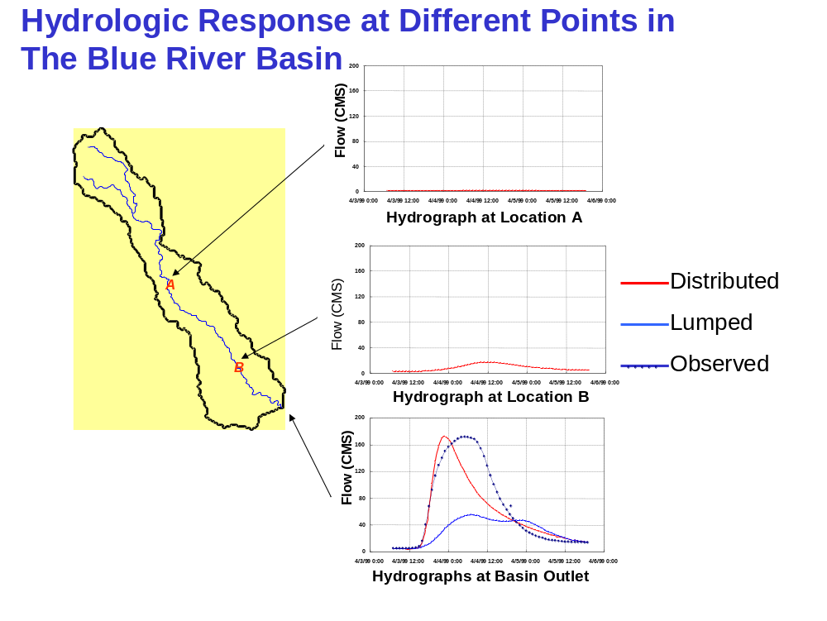
Figure 20. Hydrograph Generation at various points in the Blue River basin illustrating the use of a distributed model for flash flood forecasting at interior locations.

As an intermediate step to this strategy that can potentially use distributed model results without requiring calibration, Reed et al. (2004a) is proposing a statistical-distributed modeling approach. Perhaps the biggest potential gain from the use of distributed hydrologic models in flood forecasting is to increase the spatial resolution of forecasts. Higher resolution hydrologic forecasts can provide information in flash flood situations; however, an important question to consider in evaluating higher resolution forecasts is whether or not larger simulation uncertainties at smaller scales will diminish the utility of these forecasts, and, if so, to what degree? The statistical-distributed modeling approach is proposed to simulate floods on small basins and account for hydrologic modeling uncertainty. This modeling approach should enhance our ability to predict the occurrence of small stream and flash flooding. The approach offers an alternative to the current (NWS) Flash Flood Guidance (FFG) system and inherently addresses FFG limitations. Two goals of this study are to:

- Define, develop, and evaluate a statistical- distributed framework for predicting relative flood severity at flash flood scales (typically ungauged locations).
- In doing so, characterize hydrologic simulation uncertainties across a wide range of scales using operational quality radar-based precipitation data.

Distributed Modeling Software Engineering and Implementation

As mentioned before, a significant software engineering project is underway to develop a methodology to implement HL-RMS as an officially released and supported NWSRFC component. This is a major effort in that NWSRFS is only designed to pass time series of basin mean areal values such as precipitation, temperature, and model parameters. While NEXRAD gridded precipitation inputs can be passed into NWSRFS, these are used to create mean areal time series of precipitation which are then used as model forcing. There is no current option to generate gridded output fields in the NWSRFS.
The Distributed Modeling Systems (DMS) project was conceived to study the options for operational implementation of the HL-RMS distributed model science. A team has been formed consisting of HL scientists, software engineers, and outside software engineering contractors. The DMS project will rely heavily on the experience gained with the prototype implementations of HL-RMS at the WGRFC and ABRFC discussed in section 6.4.1.5
The interested reader is referred to the following web site for more information:
http://www.nws.noaa.gov/oh/hrl/currentprojects/dist_model/index.htm

References

Anderson, E.A., 1968. Development and testing of a snow pack energy balance equations. Water Resources Research. Vol. 4, No. 1, 19-37.
Anderson, R., Koren, V., Smith, M., and Seo, D.-J., 2003. On the importance of linear vs. nonlinear response in estimating base flow features for ungauged catchments in Southern Texas. Proceedings of the Fall Meeting of the AGU, December.
Bell, V.A., and Moore, R.J., 1998. A grid-based distributed flood forecasting model for use with weather radar data: Part 2. Case studies. Hydrology and Earth System Sciences, Vol. 2, No. 3, 283-298.
Bell, V.A., Carrington, D.S., and Moore, R.J., 2001. Comparison of rainfall-runoff models for flood forecasting. Part 2: Calibration and evaluation of models. Environment Agency R&D Technical Report W242, Research Contractor: Institute of Hydrology, September 2001, Environment Agency, 239pp.
Beven, K.J., 1985. Chapter 13, Distributed Models, in ‘Hydrological Forecasting’, M.G. Anderson, and T.P. Burt, editors, Wiley-Interscience Publication.
Boyle, D.B., Gupta, H.V., Sorooshian, S., Koren, V., Zhang, Z., and Smith, M., 2001. Toward improved streamflow forecasts: Value of semi-distributed modeling. Water Resources Research, 37(11), 2749-2759.
Boyle, D. P., Gupta, H. V., and Sorooshian, S., 2000. Toward improved calibration of hydrologic models: Combining the strengths of manual and automatic methods. Water Resources Research, Vol. 36, No. 12, 3663-3674.
Bradley A. A., and Kruger, A., 1998. Recalibration of hydrologic models for use with WSR-88D precipitation estimates. Proc. Special Symposium on Hydrology, American Meteorological Society, Phoenix, Arizona, pp. 302-305.
Burnash, R.J.C., Ferral, R.L., and McGuire, R.A., 1973. A generalized streamflow simulation system – Conceptual modeling for digital computers’, Technical Report, Joint Federal and State River Forecast Center, U.S. National Weather Service and California Department of Water Resources, Sacramento, California, 204pp.
Carpenter, T.M., and Georgakakos, K.P., 2004. Impacts of parametric and radar rainfall uncertainty on the ensemble streamflow simulations of a distributed hydrologic model. DMIP Special Issue of the Journal of Hydrology, accepted.
Carpenter, T.M., and Georgakakos, K.P., 2003. Assessing the Effects of Scale in Operational Hydrologic Modeling. HRC Limited Distribution Report No. 15, July 31, 177 pp.
Carpenter, T.M., Georgakakos, K.P., Spersflage, J.A., 2001. On the parametric and NEXRAD-radar sensitivities of a distributed hydrologic model suitable for operational use. Journal of Hydrology, 253, 169-193.
Carpenter, T.M., Georgakakos, K.P., Spersflage, J.A., 1999. Distributed Hydrologic Modeling for operational use. HRC Technical Report No. 3, August. 224 pp.
Carter, G.C., 2002. Infusing new science into the National Weather Service River Forecast System. Second Federal Interagency Hydrologic Modeling Conference, Las Vegas, Nevada, July 28-August, 10 pages. http://hsp.nws.noaa.gov/oh/hrl/presentations/fihm02/pdfs/carterpwp.pdf
Dingman, S. L., 1993. Physical Hydrology, Prentice Hall, Englewood Cliffs, NJ.
Duan, Q., Gupta, V.K., and Sorooshian, S., 1993. A shuffled complex evolution approach for effective and efficient global optimization. Journal of Optimization Theory and its Applications, Vol. 76, No. 3, 501-521.
Duan, Q., Schaake, J., and Koren, V., 2001. A priori estimation of land surface model parameters, in Laskhmi, V. et al., (Eds.), Land Surface Hydrology, Meteorology, and Climate: Observations and Modeling, Water Science and Applications 3, AGU, Washington, D.C., 77-94.
Fread, D.L., Shedd, R.C., Smith, G.F., Farnsworth, R., Hoffeditz, C.N., Wenzel, L.A., Wiele, S.M., Smith, J.A., and Day, G.N., 1995. Modernization in the National Weather Service River and Flood Program. Weather and Forecasting, 10(3), 477-484.
Georgakakos, K. P., 2002. Hydrometeorological Models for Real Time Rainfall and Flow Forecasting. In: Singh, V. P. and Frevert, D. K., (Eds.) Mathematical Models of Small Watershed Hydrology and Applications, Water Resources Publications, LLC, 593-655.
Glaudemans, M.J., Erb, R.A., Wells, E.B., Zimmerman, J., Hill-Maxwell, J., Mack, K., 2002. Overview and Status of the Hydrologic Forecast System in the National Weather Service Weather Forecast Offices. Interactive Symposium on the Advanced Weather Interactive Procesing System, (AWIPS), Orlando, Floriday, 13-17 January, pp J173-178.
Hogue, T. S., Sorooshian, S., Gupta, H., Holz, A., and Braatz, D., 2000. A multistep automatic calibration scheme for river forecasting models. J. of Hydrometeorology, Vol. 1, 524-542.
Khodatalab, N., Gupta, H. Wagener, T., and Sorooshian, S., 2004. Calibration of a semi-distributed hydrologic model for streamflow estimation along a river system. Journal of Hydrology, DMIP Special Edition, submitted.
Koren, V., Reed, S., Smith, M., Zhang, Z., Seo, Dong-Jun, 2004. Hydrology Laboratory Research Modeling System (HL-RMS) of the National Weather Service. Journal of Hydrology, in press.
Koren, V., Reed, S., Smith, M., and Zhang, Z., 2003. Combining physically-based and conceptual approaches in the development and parameterization of a distributed system. Information from Weather Radar and Distributed Hydrological Modeling, Proceedings of international symposium, IAHS Publication no. 282, Editors Tachikawa, Y., Vieux, B., and Georgakakos, K.P., 101-108.
Koren, V., Smith, M., Reed, S., and Zhang, Z., 2001. Transition from lumped to distributed modeling systems. Session H32C, AGU Spring Meeting, May 29-June 2, Boston, Mass.
Koren, V.I., Smith, M., Wang, D., Zhang, Z. 2000. Use of Soil Property Data in the Derivation of Conceptual Rainfall-Runoff Model Parameters, 15th Conference on Hydrology, 80th Annual Meeting of the AMS, Long Beach, Ca. January, 103-106.
Koren, V., and Barrett, C.B., 1994. Satellite based distributed monitoring, forecasting, and simulation (MFS) system for the Nile River. Kite, G.W., Pietroniro, A., and Pultz, T.J. (Eds) Applications of Remote Sensing in Hydrology - Proceedings of the Second International Workshop, NHRI Symposium No. 14, 18-20 October, Saskatoon, Saskatchewan, Canada, 187-200.
Kuzmin, V., Koren, V., and Seo, D.-J., 2004. Calibration of the Sacramento model: Step-wise line search, in preparation.
Larson, L.W., Ferral, R.L., Strem, E.T., Morin, A.J., Armstrong, B., Carrol, T.R., Hudlow, M.D., Wenzel, L.A., Schaefer, G.L., and Johnson, D.E., 1995. Operational responsibilities of the National Weather Service river and flood program. Weather and Forecasting, 10(3), 465-476.
Lindsey, S.D., 1994, ‘Distributed Modeling Project Plan’, Internal Publication, Hydrology Lab, NWS, February.
Lindsey, S.D., 1993, ‘Strategy for Utilizing Radar-Based Precipitation Estimates for River Forecasting’, Proceedings of the Symposium on Engineering Hydrology, ASCE, C.Y. Kuo, Editor, 940-945.
Loague, K.M., and Freeze, R.A., 1985. A comparison of rainfall-runoff modeling techniques on small upland catchments. , Water Resources Research, 21(2), 229-248.
Michaud, J., and Sorooshian, S., 1994b. Comparison of simple versus complex distributed runoff models on a midsized semiarid watershed, Water Resources Research, 30(3), 593-605.
Miller, D. A. and White, R. A., 1999. A Conterminous United States multi-layer soil characteristics data set for regional climate and hydrology modeling. Earth Interactions, 2, (available at http://EarthInteractions.org).
Moore, R.J., and Hall, M.J. eds., 2000. HYREX: the Hydrology Radar Experiment , Special Issue of Hydrology and Earth System Sciences, European Geophysical Society, 4(4).
Moreda, F.G., Zhang, Z., Koren, V., Reed, S., and Smith, M., 2003. On the parameterization of distributed models. Abstract HW08/08A/C28-005, XXIII General Assembly of the International Union of Geodesy and Geophysics-IUGG 2003 Sapporo, Japan, June 30-July 11. Full paper to be submitted to a special issue of the Journal of Hydrology dedicated to MOPEX.
Naden, P. S., 1992. Spatial Variability in flood estimation for large catchments: the exploitation of channel network structure. Hydrological Sciences Journal, 37(1),53-71.
National Academy of Sciences, 2001. Grand Challenges in Environmental Sciences, Committee on Grand Challenges in Environmental Sciences, Oversight Commission for the Committee on Grand Challenges in Environmental Sciences, National Research Council, National Academy Press.
National Research Council, 1996. Toward a New National Weather Service: Assessment of Hydrologic and Hydrometeorologic Operations and Services. National Weather Service Modernization Committee, Commission on Engineering and Technical Systems, National Academy Press.
National Weather Service, 1999: Vision 2005, National Weather Service Strategic Plan for Weather, Water, and Climate Services 2000-2005. US Department of Commerce, NOAA, Silver Spring, Maryland, 24 pp.
Obled, C. H., Wendling, J., and Beven, K., 1994. The sensitivity of hydrological models to spatial rainfall patterns: an evaluation using observed data. Journal of Hydrology, 159, 305-333.
Pessoa, M. L., Bras, R.L., and Williams, E.R., 1993. Use of weather radar for flood forecasting in the Sieve river basin: a sensitivity analysis. Journal of Applied Meteorology, 32 (3), 462-475.
Reed, S., J. Schaake, V. Koren, D.J. Seo, M. Smith, 2004a. A Statistical-distributed Modeling Approach for Flash Flood Prediction, Paper Presented at the 84th Annual Meeting of the AMS, Seattle, WA, Jan. 11-15.
Reed, S.M., Koren, V., Smith, M., Zhang, Z., Moreda, F., Seo, D.-J, and DMIP participants, 2004b. Overall Distributed Model Intercomparison Project Resutls, Journal of Hydrology DMIP Special Issue, accepted.
Reed, S., 2003. Deriving flow directions for coarse resolution (1 - 4 km) gridded hydrologic modeling. Water Resources Research, Vol. 39, No. 9.
Reed, S., Koren, V., Zhang, Z., Smith, M., Seo, D.-J., 2002. Distributed modeling for improved NWS river forecasts. Proc. the Second Federal Interagency Hydrologic Modeling Conference, Las Vegas, NV.
Rinaldo, A., Vogel, G. K., Rigon, R., and Rodriguez-Iturbe, I., 1995. Water Resource Research, Vol. 31, No. 4, 1119-1127.
Robinson, J.S., and Sivapalan, M., 1995. Catchment-scale runoff generation model by aggregation and similarity analysis. In: Scale Issues in Hydrological Modeling, J.D. Kalma and Sivapalan, M., Eds. 311-330. Wiley, New York, USA.
Singh, V. P., 1996. Kinematic Wave Modeling in Water Resources, Surface-Water Hydrology, Wiley.
Skahill, B. S., Johnson, L. E., 1999. Evaluation of Finite Difference Methods for a Distributed Rainfall-Runoff Model. NOAA Technical Memorandum ERL FSL-23, Forecast System Lab., Boulder, Colorado.
Smith, M., 1996. Distributed Modeling Project Plan, Internal NWS/OHD/HL document.13pp.
Smith, A. A., 1980. A generalized approach to kinematic flood routing. J. of Hydrology, 45, 71-89.
Smith, M.B., Seo, D. -J., Koren, V. I., Reed, S., Zhang, Z., Duan, Q.-Y., Moreda, F., and Cong, S., 2004a. The distributed model intercomparison project (DMIP): Motivation and experiment design. Accepted for publication in Journal of Hydrology DMIP Special Issue.
Smith, M.B., Koren, V.I., Zhang, Z., Reed, S.M., Pan, J. –J., and Moreda, F., 2004b. Runoff response to spatial variability in precipitation: An analysis of observed data. Accepted for publication in Journal of Hydrology DMIP Special Issue.
Smith, M. B., Laurine, D. P., Koren, V.I., Reed, S.M., and Zhang, Z., 2003. Hydrologic model calibration in the National Weather Service. In: Duan, Q., Gupta, H.V., Sorooshian, S., Rousseau, A.N., Turcotte, R., (Editors.) Calibration of Watershed Models, Water Science and Application 6, American Geophysical Union, Wash. D.C., 133-152.
Smith, M., Koren, V.I, Zhang, Z., Wang, D., and Reed, S., 2000. Semi-distributed vs Lumped model simulations: Comparison using observed data for RFC scale basins, H32F-03, Spring Meeting, Washington, DC, May 30-June 3.
Smith, M.B., Koren, V., Zhang, Z., and Wang, D., 1999a. (Invited) Semi-Distributed and Lumped Modeling Approaches: Case Study of NEXRAD Data Application to Large Headwater Basins in the Arkansas River Basin. Spring Meeting of the AGU, Boston.
Smith, M.B., Koren, V., Finnerty, B., and Johnson, D., 1999b. Distributed Modeling: Phase 1 Results. NOAA Technical Report NWS 44, US Dept of Commerce, 250 pages. Copies available upon request.
Smith, J.A., Seo, D.-J., Baeck, M.L., and Hudlow, M.D., 1996. An intercomparison study of NEXRAD precipitation estimates. Water Resources Research, 32(7), 2035-2045.
Smith, J.A., Bradley, A.A., and Baeck, M.L., 1994. The space-time structure of extreme storm rainfall in the Southern Plains. Journal of Applied Meteorology, Vol. 33, December, 1402-1417.
Stallings, E.A., and Wenzel, L.A., 1995. Organization of the river and flood program in the National Weather Service. Weather and Forecasting, 10(3), 457-464.
Stellman, K.M., and Fuelbert, H.E., 2001. An examination of radar and rain gauge-derived mean areal precipitation over Georgia Watersheds. Weather and Forecasting, Vol. 16, 133-144.
Turcotte, R., Rousseau, A.N., Fortin, J.-P., Villeneuve, J.-P, 2003. A process oriented, multiple-objective calibration strategy accounting for model structure. In Duan, Q., Gupta, H.V., Sorooshian, S., Rousseau, A.N., Turcotte, R., (Eds.), Calibration of Watershed Models, Water Science and application Volume 6, American Geophysical Union, 153-163.
Wang, M., Hjelmfelt, A. T., and Garbrecht, J., 2000. DEM Aggregation for Watershed Modeling, Journal of the American Water Resources Association, 36, 3, 579-584.
Watson, F. G. R., Gryson, R. B., Vertessy, R. A., and McMahon, T. A., 1998. Large scale distribution modeling and the utility of detailed data. Hydrological Processes, 12(6),
873-888.
Willgoose, G. And Kuczera, G., 1995. Estimation of Subgrid Scale Kinematic Wave Parameters for Hillslopes. In: Kalma, J. D. And Sivapalan, M., (Eds.) Scale Issues in Hydrological Modeling, Advances in Hydrological Processes, Wiley, 227-240.
Young, C, B., Bradley, A.A., Krajewski, W.F., and Kruger, A., 2000. Evaluating NEXRAD Multisensor Precipitation Estimates for Operational Hydrologic Forecasting. Journal of Hydrometeorology, Vol. 1, June, 241-254.
Zhang, Z., Koren, V., Smith, M.B., Use of NEXRAD data and basin disaggregation to improve continuous hydrologic simulations. Journal of Hydrologic Engineering Vol. 9, No. 2, March, 2004, 103-115.
Zhang, Z., Smith, M.B., Koren, V., Reed, S.M., Moreda, F., Kuzmin, V., and Anderson, R., 2004b. A study of the relationship between rainfall variability and the success of a distributed model. GIS and Remote Sensing in Hydrology, Water Resources, and Environment (Proceedings of ICGRHWE held at the Three Gorges Dam, China, 2003) IAHS Publication 289.

Appendix I: Publications and Presentations from Phase 1 Research

Peer Reviewed Papers from Phase 1 Research (HL Scientists in Boldface type)

Boyle, D.B., Gupta, H.V., Sorooshian, S., Koren, V., Zhang, Z., and Smith, M., 2001. Toward improved streamflow forecasts: Value of semi-distributed modeling. Water Resources Research, 37(11), 2749-2759.
Duan, Q., Schaake, J., and Koren, V., 2001. A Priori Estimation of Land Surface Model Parameters, in book ‘Land Surface Hydrology, Meteorology, and Climate: Observations and Modeling’ (Editors: V. Lakshmi, J. Albert, J. Schaake), Water Science and Application, Vol. 3, pp. 77-94, AGU, 2001’
Johnson, D., Smith, M., Koren, V., and Finnerty, B., 1999. Comparing mean areal precipitation estimates from NEXRAD and rain gauge networks. Journal of Hydrologic Engineering, Vol. 4, No. 2, April, 117-124.
Koren, V.I., Finnerty, B.D., Schaake, J.C., Smith, M.B., Seo, D.-J., Duan, Q.-Y., 1999. Scale dependencies of hydrologic models to spatial variability of precipitation. Journal of Hydrology, 217, 285-302.
Finnerty, B.D., Smith, M.B., Seo, D.-J., Koren, V., and Moglen, G.E. 1997. Space-time scale sensitivity of the Sacramento model to radar-gage precipitation inputs. Journal of Hydrology, 203, 21-38.
Schaake, J., Koren, V., Duan, Q.-Y., Mitchell, K., and Chen, F., Simple water balance model for estimating runoff at different spatial and temporal scales, 1996. JGR, Vol. 101, No. D3, 7461-7475.
Zhang, Z., Koren, V., Smith, M., Reed, S., Wang, D., 2004. Use of NEXRAD data and basin disaggregation to improve continuous hydrograph simulations. ASCE Journal of Hydrologic Engineering, Vol. 9, No. 2, March-April, 103-115.

Other Documents Resulting from Phase 1

Smith, M.B., Koren, V., Finnerty, B., Johnson, D., 1999. Distributed Modeling: Phase 1 Results, NOAA Technical Report NWS 44, February, 250pp.
Wang, D., Smith, M.B., Zhang, Z., Koren, V., Reed, S., 2001. Statistical Comparison of Mean Areal precipitation Estimates from WSR-88D, Operational, and Historical Gage Networks, Hydrology Lab. Technical Report, August.

Oral and Poster Presentations at Conferences from Phase 1 Research

Finnerty, B., and Johnson, D., 1997. Comparison of mean areal precipitation estimates derived from NEXRAD radar vs. rain gauge networks. Proceedings of Theme A, Water for a Changing Global Community, The 27th Congress of the Int’l Assoc. for Hydraulic Research, ASCE Water Resources Engineering Division, held August 10-15, San Francisco, CA., 601-606.
Koren, V., 1993. The potential for improving lumped parameter models using remotely sensed data, 1993. 13th Conference on Weather Analysis and Forecasting including Symposium on Flash Floods, Vienna, Virginia, 2 - 6 August, 1993, AMS/WMO/NWA, 397-400.
Koren, V., J. Schaake, M. Smith, B. Finnerty, D.J. Seo, and S. Tokar, 1998. Distributed/Semi-distributed and lumped approaches in runoff simulations: Numerical experiments using NEXRAD data. The Fourth International Symposium on Hydrologic Applications of Weather Radar. 5-9 April 1998, San Diego, California.
Koren, V. I., J. C. Schaake, M. Smith, 1999. Effects of Scale Aggregation and Noise in High Resolution Data on Distributed Model Results, Abstract H52A-19, AGU Spring Meeting, Boston, Massachusetts, June 1-4, 1999.
Koren, V. I., M. Smith, D. Wang, Z. Zhang, 2000. Use of Soil Property Data in the Derivation of Conceptual Rainfall-Runoff Model Parameters. 15th Conference on Hydrology, 10-15 January 2000, Long Beach, CA, AMS, 103-106.
Koren, V., M. Smith, Q. Duan, Z. Zhang, 2000. Use of a Priori Parameter Estimates in the Derivation of Spatially Consistent Parameter Sets. AGU Fall Meeting, San-Francisco, California, December 2000, H72C-08, F478. INVITED
Lindsey, S.L., 1993. Strategy for utilizing radar-based precipitation estimates for river forecasting. Proceedings of the symposium Engineering Hydrology, Hydraulics Division, ASCE, San Francisco, CA, July 25-30, 940-945.
Smith, M., Koren, V.I, Zhang, Z., Wang, D., and Reed, S., 2000. Semi-distributed vs Lumped model simulations: comparison using Observed data for RFC scale basins, H32F-03, Spring Meeting, Washington, DC, May 30-June 3.
Smith, M.B., Koren, V., Zhang, Z., and Wang, D., 1999. (Invited) Semi-Distributed and Lumped Modeling Approaches: Case Study of NEXRAD Data Application to Large Headwater Basins in the Arkansas River Basin. Spring Meeting of the AGU, Boston.
Smith, M., Koren, V., Zhang, Z., and Wang, D., 1999. Lumped and semi-distributed modeling using NEXRAD Stage III data: Results from continuous multi-year simulations. Proceedings, Georgia Water Resources Conference, Kathryn J. Hatcher, Editor, March 30,31, University of Georgia, Athens. 359-362.
Smith, M.B., Seo, D.-J., Finnerty, B.D., Koren, V., 1996. Distributed Parameter Hydrologic Modeling and NEXRAD for River Forecasting: Scale Issues Facing the National Weather Service. Presented at ASCE Conference North American Water and Environment Congress '96 Anaheim, CA, June 24-28.
Wang, D., Smith, M.B., Zhang, Z., Reed, S., and Koren, V.I., 2000. Statistical comparison of mean areal precipitation estimates from WSR-88D, operational, and historical gage networks. 15th Annual Conference on Hydrology, 80th Meeting of the AMS, Long Beach, CA., January 10-14, J2.17

Appendix II: Publications and Presentation from Phase 2

Peer Reviewed Publications from Phase 2 Research. (HL scientists in bold type).
Ek, M. B., K. E. Mitchell, Y. Lin, E. Rogers, P. Grunmann, V. Koren, G. Gayno, and Tarpley, 2004. Implementation of Noah land-surface model advances in the NCEP operational mesoscale Eta model. GCIP3 Special Issue, JGR, 2004, accepted.
Koren, V., Reed, S., Smith, M., Zhang, Z., and Seo, Dong-Jun, 2004. Hydrology laboratory research modeling system (HL-RMS) of the National Weather Service. Journal of Hydrology, in press, to appear in Special Issue.
Koren, V., Reed, S., Smith, M., and Zhang, Z., 2003. Combining physically based and conceptual approaches in the development and parameterization of a distributed system. In: Information from Weather Radar and Distributed Hydrologic Modeling, IHAS Publication No. 282, Sapporo, Japan, pages 101-108, Editors Tachikawa, Y., Vieux, B., and Georgakakos, K.P.
Koren, V., Smith, M., and Duan, Q., 2003. Use of a-priori parameter estimates in the derivation of spatially consistent parameter sets of rainfall-runoff models. In: Duan, Q., Gupta, H.V., Sorooshian, S., Rousseau, A.N., Turcotte, R., (Editors.) Calibration of Watershed Models, Water Science and Application 6, American Geophysical Union, Wash. D.C., 239-254.
Koren, V., Kogan, F. and Barrett, C., 1997. Parameterization of hydrological model using NOAA/AVHRR data. Adv. Space Res., Vol. 19, No. 3, 507-510, Pergamon.
Koren, V., and Barrett, C.B., 1995. Satellite -based, distributed monitoring, forecast, and simulation (MFS) system for the Nile River. In: ‘Appications of Remote Sensing in Hydrology’, Canada, 187-200.
Mitchell, K. E., D. Lohmann, P. R. Houser, E. F. Wood, J. C. Schaake, A. Robock, B. A. Cosgrove, J. Sheffield, Q. Duan, L. Luo, R. W. Higgins, R. T. Pinker, J. D. Tarpley, D. P. Lettenmaier, C. H. Marshall, J. K. Entin, M. Pan, W. Shi, V. Koren, J. Meng, B. H. Ramsay, A. A. Bailey, 2004. The Multi-institution North American Land Data Assimilation System (NLDAS): Utilizing Multiple GCIP Products and Partners in a Continental Distributed Hydrological Modeling System. GCIP3 Special Issue, JGR, 2004, accepted.
Reed, S.M., Koren, V., Smith, M., Zhang, Z., Moreda, F., Seo, D.-J, and DMIP participants, 2004. Overall distributed model intercomparison project results, Journal of Hydrology DMIP Special Issue, accepted.
Reed, S., 2003. Deriving flow directions for coarse resolution (1 - 4 km) gridded hydrologic modeling. Water Resources Research, Vol. 39, No. 9.
Reed, S., D. Johnson, T. Sweeney, Application and National Geographic Information System Database to Support Two-Year Flood and Threshold Runoff Estimates, Journal of Hydrologic Engineering, May/June 2002.
Seo, D.-J., Koren, V., and Reed, S., 2003. Improving a priori estimates of hydraulic parameters in a distributed routing model via variational assimilation of long-term streamflow data. In: Information from Weather Radar and Distributed Hydrologic Modeling, IHAS Publication No. 282, Sapporo, Japan, pages 109-113, Editors Tachikawa, Y., Vieux, B., and Georgakakos, K.P.
Seo, D., V. Koren, N. Cajina, 2003. Real-time assimilation of radar-based precipitation data and streamflow observations into a distributed hydrologic model. In: Information from Weather Radar and Distributed Hydrological Modeling (Eds. Tachikawa Y., Vieux. B E., Georgakakos K. P) , IAHS Publ. No. 282, Sapporo, Japan, 2003, 138-142.
Seo, D.-J., V. Koren, and N. Cajina, 2003. Real-Time Variational Assimilation of Hydrologic and Hydrometeorological Data into Operational Hydrologic Forecasting. Journal of Hydrometeorology, Vol. 4, 2003, 627-641.
Smith, M.B., Seo, D.-J., Koren, V.I., Reed, S., Zhang, Z., Duan, Q.-Y., Moreda, F., and Cong, S., 2004a. The distributed model intercomparison project (DMIP): Motivation and experiment design. Journal of Hydrology DMIP Special Issue, accepted
Smith, M.B., Koren, V., Pan, J.J., Zhang, Z. , 2004b. Runoff response to spatial variability in precipitation: An analysis of observed data. Journal of Hydrology DMIP Special Issue, accepted.
Vieux, B and Moreda, F. Ordered Physics-Based parameter adjustment of a distributed model: In AGU Monograph advances in calibration of watershed models. In Calibration of watershed models, water science and Application Volume 6. Copyright 2003 by the American Geophysical Union, pp 267-281.
Vieux, B., and Moreda, F., Nutrient Loading Assessment in the Illinois River Basin Using a Synthetic Approach. Journal of American Water Resources Association. . Vol. 39 4. P. 757-769. August 2003.
Zhang, Z., Smith, M.B., Koren, V., Reed, S.M., Moreda, F., Kuzmin, V., and Anderson, R., 2004b. A study of the relationship between rainfall variability and the success of a distributed model. GIS and Remote Sensing in Hydrology, Water Resources, and Environment (Proceedings of ICGRHWE held at the Three Gorges Dam, China, 2003) IAHS Publication 289.

Oral presentations.

Anderson, R., Koren, V., Smith, M., and Seo, D.-J., 2003. On the Importance of Linear vs. Non-Linear Response in Estimating Base Flow Features for Ungauged Catchments in Southern Texas. AGU Presentation at American Geophysical Union, San Francisco, December 9.
Anderson, R.M., Koren, V., Reed, S., Smith, M., and Kuzmin, V., 2003. Regionalization of Rainfall-Runoff Model Parameters. Presentation at International Union of Geodesy and Geophysics, Sapporo, Japan
Koren, V., S. Reed, M. Smith, Z. Zhang, 2003. Combining physically-based and conceptual approaches in the development and parameterization of a distributed system. International Union of Geodesy and Geophysics, Sapporo, Japan Sapporo.
Koren, V., M. Smith, S. Reed, Z. Zhang, 2001. Transition from Lumped to Distributed Modeling Systems. Eos, Transactions, AGU Spring Meeting, Vol. 82, No. 20, Boston, Massachusetts, May - June 2001, H32C-01. INVITED.
Koren, V., M. Smith, S. Reed, Z. Zhang, 2001. 2001. Use of NEXRAD Precipitation Estimates in Distributed Modeling: Parameterization, Aggregation Scale, and Data Uncertainties. Eos, Transactions, AGU Fall Meeting, Vol. 82, No. 47, San-Francisco, California, December 2001, H11A-0210. INVITED
Koren, V., S. Reed, Z. Zhang, D. Seo, F. Moreda, Kuzmin V., 2003. Use of spatially variable data in river flood prediction. AGU-EGS-EUG Assembly, April 9-14, 2003, Nice, France.
Moreda, F., Smith, M., Cong, S., Seo, D.-J., Zhang, Z., Reed, S., Koren, V., and Smith, M. 2002. Evaluation of NEXRAD Rainfall Data in a lumped and Distributed Hydroloic Models for a Mountainous Watershed. Eos. Trans. AGU, 83(19), Spring Meet. Supl., Abstract H51b-05.
Reed, S., J. Schaake, V. Koren, D.J. Seo, M. Smith, 2004a. A Statistical-distributed Modeling Approach for Flash Flood Prediction, Paper Presented at the 84th Annual Meeting of the AMS, Seattle, WA, Jan. 11-15.
Reed, S., J. Schaake, V. Koren, M. Smith, Z. Zhang, FFG/ThreshR: Current Issues and Future Possibilities. Poster Presented at the First National Hydrologic Program Managers Conference, New Orleans, LA, Dec. 3 – 6, 2002.
Reed, S., V. Koren, Z. Zhang, M. Smith, D.J. Seo, Distributed Modeling for Improved NWS River Forecasts, Proceedings of the Second Federal Interagency Hydrologic Modeling Conference, Las Vegas, NV, July 28-August 1, 2002.
Reed, S., V. Koren, Z. Zhang, M. Smith, Assessment of Distributed Hydrologic Routing Parameter Estimates used in NWS-HL-RMS, Poster Presentation at the 2002 Spring Meeting of the American Geophysical Union, H51B-12, May 28-31, Washington, D.C.
Reed, S., V. Koren, Z. Zhang, M. Smith, "Derivation of Routing Parameters for a Gridded Runoff Model," Oral Presentation at the 2001 Spring Meeting of the American Geophysical Union, H32C-08, Boston, MA, May 30, 2001.
Seo, D., V. Koren, L. Cajina, R. Corby, B. Finn, F. Bell, 2003. Real-time variational assimilation of streamflow and radar-based precipitation data into operational hydrologic forecasting. AGU-EGS-EUG Assembly, April 9-14, 2003, Nice, France.
Smith, M., Seo, D.J., Koren, V., Reed., S., Zhang., Z., and Moreda, F., 2003. Results from the Distributed Model Intercomparison Project (DMIP). AGU-EGS-EUG Assembly, April 9-14, 2003, Nice, France. (presented by Victor Koren)
Smith, M. Koren, V., Seo, D.-J., Reed, S., Zhang, Z., Moreda, F., Duan, Q.-Y. 2003. Distributed Models for Operational River Forecasting: Research, Development, and Implementation, Session NH-4, INVITED (presented by Victor Koren) AGU-EGS-EUG Assembly, April 9-14, 2003, Nice, France.
Vieux, B. J. Eshleman and F. Moreda. Assessing Radar to gage calibration in a distributed modeling context In the Proceedings of The Fifth International Symposium on Hydrological Application of Weather Radar. Raddar Hydrology- November 19 -22, 2001 Heian- Kaikan, Kyoto, Japan
Zhang, Z., Smith, M., Koren, V., Reed, S., Moreda, F., Kuzmin, V., and Anderson, R., 2004. A study of the relationship between rainfall variability and the improvement of using a distributed model, Proceedings of the International Conference of GIS and Remote Sensing in Hydrology, Water Resources and Environment, Three Gorges Dam site, China, 16-19 September 2003. IAHS Publication 289.
Zhang Z., Koren, V., Smith, M., and Reed., S., 2001. Application of a Distributed Modeling System Using Gridded NEXRAD Data, Proceedings, Fifth International Symposium on Hydrological Applications of Weather Radar – Radar Hydrology, 19-22, November 2001, Heian-Kaikan, Kyoto, Japan.
Zhang, Z., Koren, V., Reed, S., and Smith, M., 2002. Results from NWS Hydrology Lab’s Research Modeling System for DMIP Basins, Eos, Transactions, AGU, 83(7), 7 May 2002. Poster and oral presentations for 2002 AGU Spring Meeting (28-31 May 2002, Washington, D. C.).
Poster Presentations

Smith, M., Koren, V., Seo, D., Reed, S., Zhang, Z., Moreda, F., and Duan, Q.-Y., 2002. Evaluating the results of DMIP: How the NWS will move forward with Distributed Modeling. Poster H51B-01, Spring Meeting of the AGU, Washington, D.C., May 28-31.
Smith, M. B., Koren, V., Seo, D.-J., Reed, S., Zhang, Z., and Duan, Q., 2001. Intermediate Results from the Distributed Model Intercomparison Project (DIMP). (INVITED) Poster H12C-0310, Fall Meeting of the AGU, San Francisco, December 10-14.
Wang, D., Smith, M., Reed, S., Koren, V., and Zhang, Z., 2001. Comparison of Mean areal precipitation estimatesfrom WSR-88D and historical gage networks over Cheat River, W. Va., poster H22A-05, Spring Meeting of the AGU, Boston, May 29-June 2.

Conference Sessions Organized

Hypothesis, Theories, and Applications of Distributed Modeling and the Initial Results of the Distributed Model Intercomparison Project (DMIP) Oral. H42G, Presiding: Mike Smith, NWS, and Xu Liang, U. California Berkeley, Spring Meeting of the AGU, Washington, DC., May 28-31
Hypothesis, Theories, and Applications of Distributed Modeling and the Initial Results of the Distributed Model Intercomparison Project (DMIP) II posters. H51B , Presiding: Mike Smith, NWS, and Xu Liang, U. California Berkeley, Spring Meeting of the AGU, Washington, DC., May 28-31.
Lumped versus Distributed Modeling: Issues in Real World Applications. H32C, Presiding: Michael Smith, NWS, and Doug Boyle, Desert Research Institute, Spring Meeting of the AGU, Boston, May 29-June 2, 2001.
Lumped Versus Distributed Modeling: Issues in Real World Applications. H32F, Presiding, Michael Smith and Dong Jun Seo, NWS, Spring Meeting of the AGU, Washington D.C., May 30-June 3, 2000.
Real Time Flood Forecasting, Presiding: Victor Koren, NWS and Gabor Balint, Water Resources Research Centre (VITUKI), AGU-EGS-EUG Assembly, April 9-14, 2003, Nice, France.

Appendix III: Acronyms

ABRFC Arkansas-Red Basin River Forecast Center
API Antecedent Precipitation Index
CBRFC Colorado Basin River Forecast Center
CONUS Continental United States
DEM Digital Elevation Model
DMIP Distributed Model Intercomparison Project
DMS 1.0 Distributed Modeling System version 1.0
ESP Ensemble Streamflow Prediction
EMC Environmental Modeling Center of NCEP
FFG Flash Flood Guidance
HL Hydrology Laboratory
HL-RMS Hydrology Lab Research Modeling System
MAPX Mean Areal Precipitation estimates from NEXRAD radars
MARFC Mid-Atlantic River Forecast Center
MCP3 Manual Calibration Program version 3
MOPEX Model Parameter Estimation Experiment
MPE Multisensor Precipitation Estimator
NCEP NWS National Centers for Environmental Prediction
NWSRFS National Weather Service River Forecast System
OHD NWS Office of Hydrologic Development
RFC River Forecast Center
SAC-SMA Sacramento Soil Moisture Accounting model
WGRFC West Gulf River Forecast Center

Appendix IV: Proposed Field Office Transition from Lumped to Distributed Modeling

We propose a methodical transition from traditional lumped modeling to distributed hydrological modeling for RFC forecast operations. Our proposed methodology considers steps already being taken by many RFCs so that the implementation of an operational distributed model should not represent a significant departure from current RFC activities. For example, in many RFCs, basins are already being re-calibrated so that the models can be run on a lumped basis at a 1-hour time step rather than a 6-hour time step. Prior to the implementation of the NEXRAD series of radar platforms, RFCs were limited to a minimum 6-hour time step because of the constraints of the prevailing rain gage network. The availability of hourly rainfall estimates from NEXRAD radar platforms and in come cases dense rain gage networks has promoted this transition to a finer time scale for lumped hydrologic modeling.
As seen in step 13 of Table IV-1, a lumped hourly calibration of a basin is a desired prerequisite for the calibration of HL-RMS. Moreover, we foresee no need to discontinue the lumped hourly forecasts after a distributed model is implemented. Rather, like Bell and Moore (1998), we believe that there is merit in operating a distributed model along side a lumped model as part of a decision-support system approach to river forecasting. In a sense, the forecaster would be provided a two-member ensemble to provide guidance in the issuance of a river forecast.
Tables IV-1 and IV-2 compare the steps required to calibrate and set up a traditional lumped model within NWSRFS and the HL-RMS distributed model. These tables show that the steps required to calibrate and operationally set up a distributed model are logical, feasible, and do not represent a significant departure from current RFC procedures.

Table IV-1. Comparison of steps needed for calibration of traditional lumped model and HL-RMS distributed model.
Calibration Mode Steps Using StageIII/MPE Input Data

1 | Distributed modeling steps performed at beta test sites (HLRMS) | Lumped modeling equivalent (NWSRFS)
2 | Get observed streamflow data | Same
3 | Ensure archived StageIII/MPE data are in an accessible location | Same
4 | Get outlet lat-lon, HRAP coordinates, lat-lon, drainage area | Get drainage area and lat-lon boundaries (or line segment definition, for MAPX)
5 | Estimate channel routing parameters at outlet | Estimate unit graph (manually from hydrograph or using empirical method, e.g. IHABBs)
6 | Update channel routing parameter grids (genpar utility) | Enter unit graph into MCP3 deck
7 | Add outlet to connectivity file | Add outlet/time series information to MCP3 deck; define segment in OFS
8 | Adjust pixel areas to match USGS areas (cell-areas utility) | Not required
9 | Edit HLRMS input deck (define start and end time, other options) | Edit MCP3 Deck
10 | Not required | Run CAP to get mean a-priori parameter estimates (SAC and PE); enter values into MCP3 deck
11 | Not required | Run MAPX
12 | Run HLRMS | Run MCP3
13 | Iteratively adjust gridded parameters for the selected basin using the scale factor option to meet calibration objectives (ideal situation would be to be able to scale initial estimates based on results from a lumped calibration) | Using ICP, iteratively adjust parameter values to meet calibration objectives
14 | Plot mean precipitation, simulated, and observed time series to assist with parameter adjustments. (using XDMS or ICP) | Same, using ICP
15 | No equivalent currently available | Using ICP, examine the time variation of model states, percolation curve, and unit graph values to help with parameter adjustments
16 | Visually examine the spatial patterns of inputs, parameters, and model results. | No AWIPS-supported way to examine basin-to-basin variability of parameters.

Table IV-2 Comparison of steps required for the operational set-up of HL-RMS and a traditional lumped model

Forecast Mode Steps Using StageIII/MPE Input Data
Distributed modeling steps performed at beta test sites (HLRMS) | Lumped modeling equivalent (NWSRFS)
Complete calibration mode steps | Same
Define a new time series in OFS (PRDUTIL); edit the OFS segment definition to display the new time series (FCINIT) | ??
Edit the input deck to include the new basin | ??
Run HL-RMS (typically in batch mode) | Run OFS (typically in batch mode)
Display results in IFP or XDMS | Display results in IFP
Limited. The equivalents to run-time mods could be made to runoff states, routing states, runoff parameters, and routing parameters. Requires manual modifications to the ASCII decks and user must remember to re-enter or re-copy original values after the mods are made. | Make run time modifications
?? | Issue forecast

Appendix V: Needs for Continuing HL R&D

Aside from the major need for continued annual funding for HL scientists and extramural research collaborations, we identify several practical items needed to continue an effective R&D program:

  - As discussed earlier in Section 5.5.1, there is a great need to perform a re-analysis of the NEXRAD precipitation data to produce a high-quality data set to be used for research and calibration. Numerous authors have commented on the inconsistencies and biases in the data due to changes and updates in the NEXRAD processing algorithms. (e.g., Bradley and Kruger, 1998; Smith et al., 1999; Young et al., 2000; Stellman and Fuelberg, 2001).
  - Updates are needed for the Interactive Calibration Program (ICP) (Smith et al., 2003). HL scientists are heavily reliant on this display and analysis tool. While originally designed as an RFC tool for calibration of the SAC-SMA, SNOW-17, and other NWSRFS models, it is quite often used as a research tool because of its flexibility and ability to plot numbers of multi-year time series. The importance of ICP was clearly demonstrated at the August, 2002 DMIP workshop when all participants simulations were displayed simultaneously, facilitating an accurate assessment of model performance.
However, ICP has never ranked very high in the prioritization process for providing updates to NWSRFS software. As a result, while a few bugs have been fixed, ICP development as a research tool has been restricted. A new approach to providing updates to R&D software programs is needed that is not restricted by field-requested updates to other software systems.

